**THESIS**

**DESIGN AND IMPLEMENTATION OF STUDENT MANAGEMENT SYSTEM**

**(CASE STUDY: A.S PRIVATE HIGH SCHOOL)**

As one of the Requirements for Obtaining a Computer Bachelor Degree

Faculty of Science and Technology

University of Islam Negeri Syarif Hidayatullah Jakarta



**Supervisors,**

**A’ang Subiyakto, Ph.D**

**Evy Nurmiati, MMSI**

**PROGRAM STUDY INFORMATION SYSTEM**

**FACULTY OF SCIENCE AND TECHNOLOGY**

**UNIVERSITY OF ISLAM NEGERI SYARIF HIDAYATULLAH**

**JAKARTA**

**2020 M / 1442 H**

THIS PAGE INTENTIONALLY LEFT BLANK

**THESIS**

**DESIGN AND IMPLEMENTATION OF STUDENT MANAGEMENT SYSTEM**

**(CASE STUDY: A.S PRIVATE HIGH SCHOOL)**

As one of the Requirements for Obtaining a Computer Bachelor Degree

Faculty of Science and Technology

University of Islam Negeri Syarif Hidayatullah Jakarta



Supervisors,

A’ang Subiyakto, Ph.D

Evy Nurmiati, MMSI

PROGRAM STUDY INFORMATION SYSTEM

FACULTY OF SCIENCE AND TECHNOLOGY

UNIVERSITY OF ISLAM NEGERI SYARIF HIDAYATULLAH

JAKARTA

2020 M / 1442 H

VALIDITY SHEET

DESIGN AND IMPLEMENTATION OF STUDENT MANAGEMENT SYSTEM

(CASE STUDY: A.S PRIVATE HIGH SCHOOL)

Thesis

As one of the Requirements for Obtaining a Computer Bachelor Degree

Faculty of Science and Technology

University of Islam Negeri Syarif Hidayatullah Jakarta

By:

**ABDUL SABOOR HAMEDI**

11160930000120

Approved by,

Supervisor I Supervisor II

**A’ang Subiyakto, Ph. D Evy Nurmiati, MMSI**

NIP. 197602192 00710 1 002 NIP. 19780215 201411 2 003

**Knowing**,

Head of Information System

**A’ang Subiyakto, Ph.D.**

NIP. 197602192 00710 1 002

# **ABSTRACT**

**ABDUL SABOOR HAMEDI (11160930000120) Design and Implementation of Student Management System (Case Study: A.S Private High School)** under the guidance of **A’ANG SUBIYAKTO, PH.D**. and **EVY NURMIATI, MMSI**.

This thesis shows how to replace the manual system with a computer system in a school. A.S Private High School is located in Afghanistan, it founded on January 1, 2010, the system of the school is still manual, the information about the student, teacher, family, and other staffs saving in a notebook, this system is insecure at the same time very expensive comparing to the student management system. With the manual system, there is no privacy for teachers as well as students, it is difficult for a student to note the schedule, it is not preferable to announce the grades in front of the class, it takes time to come to school and ask your grades. To solve this problem, the researcher used Rapid Application Development (RAD) agile software development, this method is recognized as an efficient method for the student management system, this method changes manual system to a computer system where a student, teacher can have their account, and a teacher can upload student’s grades, share a file, and students can receive them at the same time no need to wait. Administration or management have full right on the system, the administration can add, update, delete new student as well as teacher, administration is responsible for creating class, schedule, and add full information about students. This system is running on the browser, chrome, Firefox, Microsoft Edge, and other browsers. We used Pure PHP to write the code, MySQL to save data, style cascade sheet 3 (CSS3) to design the system, Unified Modeling Language (UML) to visualize the system.

**Keywords**: Knowledge management system, A.S Private High School, tacit knowledge, explicit knowledge, Rapid Application Development, Unified Modeling Language, PHP, MySQL, HTML, CSS.

V Chapter + 208 Pages + 58 Images + 32 Tables + Table of content + References + Appendix

# **FOREWORD**

In the name of Allah SWT The Most Beneficent and The Most Merciful. All praises are to Allah SWT for all blesses so that the writer can accomplish this thesis. Also, peace and blessing to prophet Muhammad (PBUH) who has taken all human beings from the darkness to the lightness.

Alhamdulillahirobbil’alamin, praise and gratitude only to Allah SWT, the glorious, the lord, and the all-mighty, the merciful and the compassionate, who has given bless and opportunity for the researcher to finish the paper titled *Design and Implementation of Student Management System.*

This thesis aims to develop a complete student management system, to enhance and standardize the school system, this system can register students and save the data inside the database and display it back in an electronic page.

In the process of writing this thesis writer got so many help, motivation, and guidance from people, furthermore, the write would like to express his genuine gratitude to:

1. Mrs. Prof. Dr. Lily Surraya Eka Putri, M. Eka. Stud. The deen of faculty of science and technology UIN Syarif Hidayatullah Jakarta.
2. Mr. A’ang Subiyakto, Ph.D. The head of science and technology UIN Syarif Hidayatullah Jakarta as well as my first supervisor, Mr. A’ang always courage us to study hard and finish your study on time, he has a nice personality and always being kind to everyone in faculty of science and technology, especially with international students.
3. Mrs. Nida’ul Hasanati, S.T. MMSI secretary of faculty of science and technology UIN Syarif Hidayatullah Jakarta.
4. Mrs. Evy Nurmiati, MMSI, lecturer of UIN Syarif Hidayatullah Jakarta. I strongly appreciate all of her efforts and hard-working, she always treated me like her son.
5. I would love to thanks my father, my mother, without their supports it would impossible to continue my study abroad, it’s because of them I’m in this stage of my life.
6. I would like to thanks the International office of the University of Islam Negeri Syarif Hidayatullah Jakarta, they are kind to international students, I cannot forget what they have done to us to finish our study.
7. I would like to thanks my classmates for their tolerance, respect, and helps.
8. We were four international students in one class from the first semester until the end, I will never forget those beautiful moments, they have always inspired me to study hard and become what I want to be, thank you to all of them.
9. In the end, I apologize for any mistake I have done intentionally or unintentionally and I also want to forget everyone just for the sake of Allah S.W.T anyone who did evil for me or made me disappointed I forgive everyone, I hope Allah S.W.T forgive us all.

Thank you very much

Wassallamuallikum Warramtuallahi Wabarakatuh

Jakarta, August 2020

**Abdul Saboor Hamedi**

11160930000120

**ABSTRACT** V

**FOREWORD** VI

**TABLE OF FIGURE** XVII

**CHAPTER I** 11

**INTRODUCTION** 11

**1.1** **Background** 11

**1.2** **Identification of Problem** 16

**1.3** **Problem formulation** 16

**1.4** **Limitation of Study** 17

**1.5** **Research Objectives** 17

**1.6** **Benefits of Research** 18

**1.9** **Writing System** 19

**CHAPTER II** 22

**THEORETICAL FRAMEWORK** 22

**2.1** **Information Management System** 22

**2.2** **Design concepts** 23

**2.3** **Concept of Information System** 23

2.3.1 Information 23

2.3.2 System 24

2.3.3 Understanding of Information System 24

2.3.4 Components of the information system 26

2.3.4.1 Computer hardware 26

2.3.4.2 Computer software 26

2.3.4.3 Database 26

2.3.4.4 Network 26

2.3.4.5 Human Resources 26

**2.4 Concept of Knowledge management** 27

2.4.1 Understanding of knowledge 27

2.4.2 Types of knowledge 28

2.4.2.1 Explicit knowledge: 28

2.4.2.2 Tacit knowledge: 29

2.4.3 Difference of tacit and explicit 29

2.4.4 Knowledge conversion 30

2.4.4.1 Form tacit to tacit (socialization) 31

2.4.4.2 Form explicit to explicit (Internalization) 32

2.4.4.3 Form Tacit to explicit (Combination) 32

2.4.5 Understand of Knowledge Management 33

2.4.6 Knowledge management activities 35

2.4.6.1 Knowledge Identification 35

2.4.6.2 Knowledge Acquisition 36

2.4.6.3 Knowledge Application 36

2.4.6.4 Knowledge sharing 36

2.4.6.5 Knowledge Development 37

2.4.6.6 Knowledge Creation 37

2.4.6.7 Knowledge preservation 38

2.4.6.8 Knowledge Measurement 38

2.4.7 Benefits of knowledge management 38

2.4.8 Understanding knowledge management system 40

**2.5** **Human Resources Management (HRM)** 43

**2.6** **Method of data collecting** 44

2.6.1 Observation 44

2.6.2 Literature review 44

2.6.3 Interview 45

**2.7** **Rapid application development method (RAD)** 45

2.7.1 Key benefits of RAD 46

2.7.2 RAD stages 47

2.7.2.1 Stage Requirements planning 47

2.7.2.2 Stage User Design 48

2.7.2.3 Stage Rapid construction 48

2.7.2.4 Stage Cutover 49

2.7.3 Strengths and weakness of RAD 49

**2.8** **SDLC (System Development Life Cycle)** 50

2.8.1 Definition SDLC 50

2.8.2 SDLC Phases Model 50

**2.9** **Prototyping** 51

2.9.1 Understanding of Prototyping 51

2.9.2 Advantages of prototype 52

**2.10**  **System Testing** 53

2.10.1 Black-box testing 53

2.10.2 White-box testing 54

**2.11 Unified Modeling Language (UML)** 54

2.11.1 Use case diagram 55

2.11 2 Activity Diagram 57

2.11.3 Class Diagram 58

2.11.4 Sequence Diagram 59

**2.12**  **Database Concepts** 64

2.12.1 Understanding of Database 64

**2.13**  **MySQL Database** 65

**2.14**  **System Testing Tools** 66

2.14.1 PHP 66

2.14.2 XAMMP and phpMyAdmin 66

**2.15**  **Visual Studio Code** 67

**CHAPTER III** 63

**RESEARCH METHODOLOGY** 63

**3.1** **Method data collecting** 63

3.1.1 Observation 63

3.1.2 Interview 63

2.1.3 Literature review 64

**3.2** **System development method** 72

3.2.1 Requirement Planning 72

3.2.2 Design stage 73

**3.2.3** **Implementation stage** 73

3.2.4 Reasons for using Rapid Application Development 74

3.2.5 Reasons for using Black-box testing 75

**3.3** **Mind Mapping** 76

**CHAPTER IV** 77

**SYSTEM ANALYSIS AND DESIGN** 77

**4.1** **Requirement Planning** 77

4.1.1 General description of A.S High School 77

4.1.1.1 Profile of A.S High School 77

4.1.2 Vision, Mission, and Value of School 78

4.1.2.1 Vision 78

4.1.2.2 Mission 78

4.1.2.3 Value 78

**4.1.3** **Logo of A.S Private High School** 79

**4.1.4** **Structure of A.S Private High School** 80

4.1.5 Duties of A.S Private High School 80

4.1.6 SECI Model 81

4.1.6.1 Socialization 81

4.1.6.2 Externalization 81

4.1.6.3 Combination 82

4.1.6.4 Internalization 82

4.1.7 Core Process Analysis 82

4.1.7.1 Knowledge Acquisition 82

4.1.7.2 Knowledge Development 82

4.1.7.3 Knowledge sharing 83

4.1.7.4 Knowledge Utilization 83

4.1.7.5 Knowledge Retention 83

4.1.7.6 Knowledge Goals 83

4.1.8 Knowledge management analysis 84

4.1.8.1 Problem analysis 84

4.1.8.2 Component Diagram 84

4.1.8.3 Zero level Data flow diagram (Zero Level DFD) 85

4.1.8.4 First level Data flow diagram (1st level DFD) 87

4.1.8.5 Second level data flow diagram (2nd level DFD) 88

4.1.8.6 Current Process 89

4.1.8.7 System Requirements Analysis 90

4.1.8.8 Proposed System 91

**4.2 Design Workshop** 91

4.2.1 Use Case Diagram 91

4.2.2 Activity Diagram 105

4.2.3 Class Diagram 118

4.2.4 Mapping Cardinality 119

4.2.5 Sequence Diagram 120

4.2.6 Crud Matrix 115

4.2.7 Database Scheme 120

4.2.8 Database Specification 121

4.2.9 Menu Structure Design 132

**4.3.1** **Interface Design** 133

**4.4** **Implementation** 144

4.4.1 Testing 144

**CHAPTER V** 142

**CLOSING** 142

**5.1 Conclusion** 142

**5.2 Suggestion** 143

**REFERENCES** 144

**APPENDIX 1** 148

**INTERVIEW** 148

**THESIS ACKNOWLEDGEMENT** 150

**APPENDIX 2** 151

**LETTERS** 151

**APPENDIX 2** 152

**USER INTERFACE** 152

# **TABLE OF FIGURE**

Figure: 2. 1 Knowledge conversion Nonaka (1994) 31

Figure: 2. 2 Schema of Individual Knowledge Needs 35

Figure: 2. 3 RAD stages 47

Figure: 2. 4 SDLC Phases Model 51

Figure: 2. 5 Prototype model process 52

Figure: 2. 6 Use Case Diagram 56

Figure: 2. 7 Manage users and full application 58

Figure: 2. 8 Class Diagram 59

Figure: 2. 9 Administration Sequence diagram 60

Figure: 2. 10 Admission Sequence Diagram 61

Figure: 2. 11 Student Sequence Diagram 62

Figure: 2. 12 Teacher Sequence Diagram 63

Figure: 3. 1 Mind Mapping 76

Figure: 4. 1 Logo A.S Private High School 79

Figure: 4. 2 Structure of A.S Private High School 80

Figure: 4. 3 Component Diagram of school 85

Figure: 4. 4 Zero levels of DFD 86

Figure: 4. 5 First-level Of DFD 87

Figure: 4. 6 Second-level of DFD 88

Figure: 4. 7 Rich Picture Current Process 89

Figure: 4. 8 Rich Picture Propose System 90

Figure: 4. 9 Rich Picture of Use Case 95

Figure: 4. 10 Login Activity Diagram 107

Figure: 4. 11 Manage users and full application Activity diagram 108

Figure: 4. 12 Create new administration Activity Diagram 109

Figure: 4. 13 Create student and teacher Activity Diagram 110

Figure: 4. 14 Add new parent Activity Diagram 111

Figure: 4. 15 Add info about family Activity Diagram 112

Figure: 4. 16 Create an account for student and teacher 113

Figure: 4. 17 Create new classes Activity Diagram 114

Figure: 4. 18 Create new schedule Activity Diagram 115

Figure: 4. 19 Share file Activity Diagram 116

Figure: 4. 20 Logout Activity Diagram 117

Figure: 4. 21 Class Diagram 118

Figure: 4. 22 Mapping Cardinality 119

Figure: 4. 23 Login Sequence Diagram 120

Figure: 4. 24 Logout sequence 121

Figure: 4. 25 administration Sequence Diagram 122

Figure: 4. 26 Admission Sequence Diagram 123

Figure: 4. 27 Student Sequence Diagram 124

Figure: 4. 28 Teacher Sequence Diagram 125

Figure: 4. 29 Database Schema 120

Figure: 4. 30 Admin Menu Application 132

Figure: 4. 31 Login Interface Design 133

Figure: 4. 32 Dashboard Interface Design 134

Figure: 4. 33 Student Interface Design 135

Figure: 4. 34 Teacher Interface Design 136

Figure: 4. 35 Teacher add the grade 136

Figure: 4. 36 Register Student Interface Design 137

Figure: 4. 37 Update Student Interface Design 137

Figure: 4. 38 Add New Teacher 138

Figure: 4. 39 Update Teacher 139

Figure: 4. 40 Settings Interface Design 140

Figure: 4. 41 Add New Family 140

Figure: 4. 42 Add New Parent 141

Figure: 4. 43 Add New Classes 141

Figure: 4. 44 Add New Grades 142

Figure: 4. 45 Add New Subject 143

**LIST OF TABLES**

Table: 2. 1 Properties of a use case 57

Table: 2. 2 Comparative Study of Literature 65

Table: 4. 1 Actor Identification 91

Table: 4. 2 Use Case Diagram Identification 92

Table: 4. 3 Login Narrative Diagram 96

Table: 4. 4 Manage user and full application Narrative Diagram 97

Table: 4. 5 Create new administration Narrative Diagram 98

Table: 4. 6 Register student, teacher Narrative Diagram 98

Table: 4. 7 Add new parent Narrative Diagram 99

Table: 4. 8 Add info about family Narrative Diagram 100

Table: 4. 9 Add info about family Narrative Diagram 101

Table: 4. 10 Create new classes Narrative Diagram 102

Table: 4. 11 Create new schedule Narrative Diagram 103

Table: 4. 12 Share files Narrative Diagrams 104

Table: 4. 13 Logout Narrative Diagram 105

Table: 4. 14 Crud Matrix 119

Table: 4. 15 User Specification 121

Table: 4. 16 Admin Specification 122

Table: 4. 17 Student Specification 123

Table: 4. 18 Family Specification 124

Table: 4. 19 Parents Specification 125

Table: 4. 20 Parents Specification 126

Table: 4. 21 Subjects Specification 127

Table: 4. 22 Teacher Specification 128

Table: 4. 23 Grades Specification 129

Table: 4. 24 Years Specification 130

Table: 4. 25 Professions Specification 130

Table: 4. 26 Share file Specification 131

Table: 4. 27 Testing Login Menu 144

Table: 4. 28 Testing Dashboard Menu 145

Table: 4. 29 Testing Student Menu 145

Table: 4. 30 Testing Teacher Menu 146

**LIST OF SYMBOLS**

|  |  |  |
| --- | --- | --- |
| Symbol | Name | Information |
|  | Use Case | Use case diagrams show business use cases, actors, and the relationships between them. The relationships between actors and business use cases state that an actor can use certain functionality. |
|  | Actor | Actors are the users of a system. When one system is the actor of another system, label the actor system with the actor stereotype. |
|  | Association | An association is a relationship between an actor and a business use case. It indicates that an actor can use certain functionality of the business system in the business use case. |
| Extend | Extend | Extends is a direct relationship  That specifies how and when the behavior defined in usually supplementary optional extending use case can be inserted into the behavior defined in the extended use case. |
| Include | Include | Use case include is a directed relationship between two use cases  that is used to show the behavior of the included in a use case. |

Activity diagram symbols

|  |  |  |
| --- | --- | --- |
| Symbol | Name | Information |
|  | Initial Status | Initial status shows the initial state of the workflow, meanwhile, the final state display the final state of a workflow. |
|  | Activity | Activity in unified modeling language (UML) is a major task that must take place to fulfill an operation contract. |
|  | decision | Decision activity is introduced UML to support conditional in activities. A decision activity is modeled as a diamond on a UML activity diagram. |
|  | Join | A join node joins multiple concurrent flows back into a single outgoing flow. |
|  | Final state | Identify the initial state and the final terminating states. |
|  | Swimlane | A swimlane diagram is a type of flowchart that delineates who does in a process. |

Symbol class diagram

|  |  |  |
| --- | --- | --- |
| Symbol | Name | Information |
| Description: D:\class.PNG | Class | Class is a type of static structure diagram. |
| Description: D:\assoo.PNG | Association | Association is a relationship between classifiers which is used to show that instances of classifiers could be either linked to each other or combined logically or physically some aggregation. |
| Description: D:\generalisation.PNG | Generalization | Generalization is the process of extracting shared characters from two or more classes and combining them into a generalized superclass. |
| Description: D:\cardinality.PNG | Cardinality | In (UML) cardinality represent by the character “…1” meaning that the first entity class can be associated with an unlimited number of instances of a second class. |
| Description: depedency.png | Dependency | A dependency diagram is a graphical display of all the tasks in a workflow that are required to complete a request. |

Symbol sequence diagram

|  |  |  |
| --- | --- | --- |
| Symbol | Name | Information |
| Description: D:\Kampus\SKRIPSI\BAHAN\New folder\hidhgsa.png | Actor | Actors are the users of a system. When one system is the actor of another system, label the actor system with the actor stereotype. |
|  | Lifeline | A lifeline represents an individual participant in a sequence diagram. |
|  | Boundary | A boundary class is a class to model interaction  Between the system’s surroundings and its inner working. |
| Description: D:\Kampus\SKRIPSI\BAHAN\New folder\sdgvdjobv.png | Entity | An entity is a collection of fields and associated database operations. |
|  | Message | The argument of the message contains the information that is attached to the message. |
|  | Self-Message | A self-massage reflects a new process or method invoked within the calling life-line’s operation. |
| Description: D:\Kampus\SKRIPSI\BAHAN\New folder\vbavlba.png | Control | The Control class represents sequencing, transactions, and control of the other objects. |

# **CHAPTER I**

# **INTRODUCTION**

# **1.1 Background**

Knowledge management (KM) was initially defined as the process of applying a systematic approach to the capture, structure, management, and dissemination of knowledge throughout an organization in order to work faster, reuse best practices, and reduce costly rework from project to project (Nonaka and Takeuchi, 1995; Pasternack and Viscio, 1998; Pfeiffer and Sutton, 1999; Ruggles and Holtshouse, 1999).

Knowledge management is a business activity with two primary aspects:

Treating the knowledge component of business activities as an explicit concern of business reflected in strategy, policy, and practice at all levels of the organization; and, making a direct connection between an organization’s intellectual assets both explicit (recorded) and tacit (personal know-how) and positive business results. (Barclay and Murray, 1997) Knowledge management is a collaborative and integrated approach to the creation, capture, organization, access and use of an enterprise’s intellectual assets. (Grey, 1996)

Knowledge the insights, understandings, and practical know-how that we all possess is the fundamental resource that allows us to function intelligently. Over time, considerable knowledge is also transformed to other manifestations such as books, technology, practices, and traditions within organizations of all kinds and in society in general. These transformations result in cumulated expertise and, when used appropriately, increased effectiveness. Knowledge is one, if not THE, principal factor that makes personal, organizational, and societal intelligent behavior possible. (Wiig, 1993, pp. 38–39).

Knowledge management is the concept under which information is turned into actionable knowledge and made available effortlessly in a usable form to the people who can apply it. (Information Week, Sept. 1, 2003).

Wiig (1993) also emphasizes that given the importance of knowledge in virtually all areas of daily and commercial life, two knowledge-related aspects are crucial for viability and success at any level. These are knowledge assets that must be applied, nurtured, preserved, and used to the largest extent possible by both individuals and organizations; and knowledge-related processes to create, build, compile, organize, transform, transfer, pool, apply, and safeguard knowledge that must be carefully and explicitly managed in all affected areas.

Knowledge management is a surprising mix of strategies, tools, and techniques some of which are nothing new under the sun. Storytelling, peer-toper mentoring, and learning from mistakes, for example, all have precedents in education, training, and artificial intelligence practices. Knowledge management makes use of a mixture of techniques from knowledge-based system design, such as structured knowledge acquisition strategies from subject matter experts (McGraw and Harrison-Briggs, 1989) and educational technology (e.g., task and job analysis to design and develop task support systems; see Gery, 1991).

To understand how the design and structure of management information system works, we should walk through three levels of management namely strategic management, management control (tactical management), and operational management (Gabriel, 2012). Therefore, developers need to understand system analysis and database design.

Several journals have been reviewed based on the current research, here are the journals as follows:

“School knowledge management framework, and strategies the new perspective on teacher and professional development”.

This paper is concerned about how schools use knowledge management strategies to promote and enable teachers to learn to upgrade teacher professional growth, so that the teaching profession can advance with the times, thus improving the quality of education (17 November, Jingyuan Zhao, 2009).

The second journal which is based on the current research is as follows:

“Powerful public sector knowledge management”.

This paper is drawn from a recent research study exploring the Toronto District School Board’s efforts to initiate and improve early literacy instruction and achievement. More specifically, this paper highlights the District’s focus on creating and enhancing opportunities for literacy-based knowledge sharing between teachers and leaders.

The third journal is based on the current the current search:

“Student Appreciation Toward Online Learning Management System”

Research in the field of information and communication technology in education shows a positive effect of e-learning application in learning activities. That is the result of Singh's research "A Study into the Effects of eLearning on Higher Education"(Handal, 2009: 50).

A.S Private High School is located in Afghanistan, it founded on January 1, 2010, the system of the school is still manual, the information about the student, teacher, family, and other staffs saving in a notebook, this system is insecure at the same time very expensive compare to the student management system.

With the old system, the privacy is not safe, especially about the grades, the grades are one of the student’s privacy, every student achieves their grades in front of the class by calling the student names, and everyone else can know the grade of each other.

The scheduling system is too hard and it takes a lot of time to note the schedule, every teacher is responsible to write down the schedule on the board, and every student should note it, some students cannot note it, and ask for help.

The main goal is to enhance the performance of A.S Private High School by implementing the student management system. This system has developed based on school requirements. With the student management system, A.S Private High School will have a fast and secure system, every student and teacher have their accounts, teachers and students can check the schedules, the teacher can add grades for students. The student management system handling by the management or (admin) of the school.

The student management system can handle all details about students, teachers, and staff, but in this thesis, researcher have been focused on the student side, like student registration, make online class, schedule, upload grades for each student. The system has been built in pure PHP computer language, the data saved on MySQL database, researcher used cascade stylesheet (CSS3) which the latest version at the time.

# **1.2 Identification of Problem**

The problem identification derived from the background, the problems are listed as follows:

1. A.S Private High School still uses the manual system, the data about students, teachers, and staff are saving in a notebook.
2. Students have no privacy based on the grading system, everyone knows each other's grades.
3. Teachers cannot share their knowledge properly, because of the less facility.

# **1.3 Problem formulation**

Problem formulation is derived from problem identification, the problem formulation.

1. Nowadays technology is very advanced and useful, how to equip A.S Private High School to have a standard system?
2. How to reduce time consuming, and provide more facilities for students to make study more easy?
3. How to enable the teachers to share their knowledge in more efficient way?

# **1.4 Limitation of Study**

This thesis is focusing on the core problems, for that reason, this research is limited which is as follows:

1. The scope of this study is conducted in A.S Private High School which is located in Afghanistan.
2. Rapid Application Development used to build the system

Using Unified Modeling Language (UML) to demonstrate our design, the components like Class Diagram, Use Case, Activity Diagram, and Sequence Diagram.

1. The system was developed based on pure PHP, and cascade stylesheet 3 (CSS3) to design our system.
2. The database was created using MySQL.

# **1.5 Research Objectives**

This objective is based on the problem formulation, A. S Private High School expect the student management system, to enhance the school performance.

To build the system first researcher needs to have enough information about the school, and a solid design to create the system based on the design, and a computer language to write the code, researcher chooses PHP language to write the code, and MySQL to save the data.

# **1.6 Benefits of Research**

The very first benefit of this thesis to understand more about the student management system, and how to replace the manual system with the computer system. The second benefit of this thesis researcher has talk a lot about knowledge management and management information system, this thesis would enable you to understand knowledge management with more details.

# **1.9 Writing System**

This Thesis is divided into some chapters. Those chapter are:

**CHAPTER I: INTRODUCTION**

This chapter contains background research, problem identification and problem statement, scope of work, objectives, thesis benefits, and systematic writing.

**CHAPTER II: THEORETICAL FRAMEWORK**

This chapter contains theory used in writing this research thesis, including fundamental of system development, information system, Rapid Application Development (RAD) methodology used in this research and a tools researcher used to develop the student management system to control application such as a tool to design the application and a tools to construct the application. In the last, a technique that will be used to test the application.

**CHAPTER III: METHODOLOGY**

This chapter will explain about the methodology used in the application. Including data collection and method of application development. It also explains the process for data collection and application development

**CHAPTER IV: SYSTEM ANALYSIS AND DESIGN**

This chapter contains result and discussion about this research. It describes processes in developing student management system at every stage starting from analyzing the current business process and propose a new system process. After that, designing a propose system process using UML tools starting from use case, activity diagram, sequence diagram, class diagram, and database. Next, constructing the system based on the design that already created, pure PHP, MySQL, CSS3. In the last, testing each of functions within the system whether is it already running supposed to be or not.

**CHAPTER V: CLOSING**

The summary of the research is based on problem limitation and possibilities of future works in developing this application given in the last chapter.



# **CHAPTER II**

# **THEORETICAL FRAMEWORK**

# **2.1 Information Management System**

As explained (Gabriel,2012) respectively converged in opinions that defining management information systems would first require splitting the subject into three facets of, Management, Information, and Systems respectively. Accordingly, Kumar defined management as the process through which planning, organizing, initiating, and controlling of operations within a business is carried out in 2006.

Based on (Kumar, 2006), to define MIS, it must be principally divided into the three facets that constitute it which are, management, information, and systems. according to his ideas, Kumar simply defines management as the process through which managers plan, organize, initiate, and control operations within their businesses. Essentially, management can only exist when there are subjects, workers to be managed (Al-Zhrani, 2010, p.1248-1252; The Maniac, n.d.).

*Kuman* also mentioned that information generally points to analyzed data. On the other hand, information with regards to business results from data that is analyzed using business status, principles.

# **2.2 Design concepts**

The main aim of information design is clarity of communication, to finish this aim all messages must be accurately designed, produced, and distributed and late correctly interpreted and grasp by members of the intended audience. As an area of knowledge information design has a solid foundation, which can be expressed using four basic statements, or prerequisites: Multidisciplinary, Multi-dimensional, Theory and Practice, and There Are No Firm Rules ((Pettersson, 2007).

There are three types of intellectual capital, (human capital), or the (knowledge), (skills), and capabilities possessed by individual employees, organizational capital, or the institutionalized knowledge and codified experience residing in databases, manuals, culture, systems, structures, and processes, and social capital, or the knowledge embedded in relationships and interactions among individuals (Subramaniam and Youndt, 2005).

# **2.3 Concept of Information System**

## 2.3.1 Information

According to (Beaver, 2012), the term is indeed vague and still an important part of the modern linguistic landscape. We are live in the information age and we are in touch with information every day, we carry information with us nowadays, we are having more information than ten years back.

The expression: philosophy of information was coined in the 1990s by the abovementioned Luciano Floridi, who elaborated a unified and coherent, conceptual frame for the whole. (Floridi, 2010) identified five different kinds of information: *mathematical, semantic, physical, biological, and economic, but this list is not definitive.*

According to Floridi, four kinds of mutually compatible phenomena are commonly referred to as "information":

• Information about something (e.g. a train timetable)

• Information as something (e.g. DNA, or fingerprints)

• Information for something (e.g. algorithms or instructions)

• Information in something (e.g. a pattern or a constraint)

## 2.3.2 System

The word system is derived from the Greek word “system” which means the organized relationship among the functioning units. However, the word system always comes with an adjective, whenever we talk about a system such as the educational system, political system, accounting system, etc.

## 2.3.3 Understanding of Information System

Information systems are among the foremost relevant components of the present business environment. they provide great opportunities for fulfillment for the companies; as long as they need the potential of collecting, processing, distributing and sharing data in an integrated and timely manner. Furthermore, they assist narrow geographical gaps, allowing employees to be more efficient, which is reflected in an improvement of the processes, administration, and therefore the management of data, thus leading to a positive impact on the productivity and competitiveness of the businesses (Bakos & Treacy, 1986; Rai, Patnayakuni, & Seth, 2006; Ynzunza & Izar, 2011).

This investigation has the objective of determining the influence of the success of the IS on the organizational results (OR). For a company, the OR allow measuring its operational efficiency (Sedera & Gable, 2004). In this scope, the model developed by DeLone and McLean (1992, 2003) to evaluate the success of the IS has proven to be a useful framework to deduce its success or effectiveness (Petter, DeLone, & McLean, 2013) by recognizing that the quality dimensions of the IS are a distinctive characteristic of the perception of the user in the use of new technologies (Solano, García, & Bernal, 2014); thus, achieving a positive impact on the individual and organizational performance (DeLone & McLean, 2003).

On the other hand, the Information system contains information about significant people, places, and things within the organization or the environment surrounding it. By information, we mean data that are shaped into a form that's meaningful and useful to the citizenry. Data, in contrast, are streams of raw facts representing events occurring in organizations or the physical environment before they need to be organized and arranged into a form that folks can understand and use.

## 2.3.4 Components of the information system

Information systems (IS) are formal, social-technology, an organizational system designed to collect, process store, and distribute information. In a social-technology perspective, information systems are composed of five components, the components are:

### 2.3.4.1 Computer hardware

### 2.3.4.2 Computer software

### 2.3.4.3 Database

### 2.3.4.4 Network

### 2.3.4.5 Human Resources

Computer hardware: Physical equipment used for input, output, and processing, what are hardware or physical components used it depends upon the type and size of the companies.

Computer software: The software control and coordinate the hardware components, it is used for analyzing and processing data. These programs involved a set of instructions used for processing information.

Software divided into three types:

1. System Software
2. Application Software
3. Procedures

Database: Dates are the facts and figures that are unorganized that are not later processed to generate information. We are using software for organizing and work for users, controlling the physical storage of media and virtual resources.

Network: Networks concern to telecommunication networks like the internet, extranet,

These things brought so many facilities to the societies.

Human Resources: It is related to the human-power required to launch the system, people are the end-user of the information system, end-user use information produced for their purpose. ­

# **2.4 Concept of Knowledge management**

## 2.4.1 Understanding of knowledge

Knowledge isn't a simple concept to debate. to know what knowledge is, it's important to know how it relates to data and knowledge. generally, past literature has identified the distinctions between data, information, and knowledge. Data is usually described as a group of discrete, objective facts about events; while information may be a collection of knowledge and associated explanations, interpretations, and other textual material concerning a specific object, event, or process.

Knowledge on the opposite hand may be a more complex concept to define. Bergeron (2003) defined it as information that's organized, synthesized, or summarized to reinforce comprehension, awareness, or understanding. Similarly, (Karlsen and Gottschalk,2004) defined knowledge as information combined with experience, context, interpretation, reflection, intuition, and creativity. In short, knowledge far and away is more comprehensive and more valuable compared to information and data. it's mainly attached to the individual who owns and uses it and manifests itself in many various ways. For example, we will see knowledge at work by the way people make decisions, by a particularly peculiar way people do their jobs, and through people’s creativity in completing their work.

## 2.4.2 Types of knowledge

Knowledge in an organization is often classified into two types: explicit and tacit

**2.4.2.1 Explicit knowledge:** People have always passed their accumulated knowledge and commercial wisdom on to future generations by telling stories about their thoughts, work, and experiences. Now, as in the past, people use face-to-face and ’hands-on’’ methods to convey their ’know-how’ or tacit knowledge to others (Hansen et al, 1999).

As we are living in an advanced world explicit knowledge can be captured and written down in documents or databases. A good example could be proper instruction, making good procedures.

**2.4.2.2 Tacit knowledge:** Tacit is the knowledge that people carry in their heads. It is much less concrete than explicit knowledge. It is more of an unspoken understanding about something, a knowledge that is more difficult to write down in a document or a database.

## 2.4.3 Difference of tacit and explicit

Knowledge could also be explicit or tacit. Explicit knowledge is stored in documents and other storage systems. It is often shared and expressed. Tacit knowledge on the opposite hand is stored within the human mind and includes intellect, experience, thoughts, intuitions, for more see **table 1.1**

It enhances experience and efforts. it's hard to formalize, communicate, record, and share such knowledge. The tacit knowledge helps a corporation to capitalize and attain an advantage over the others. the specific and therefore the tacit knowledge complement one another and add value to the organization’s performance.

#### Table 1.1 Explicit and Tacit

|  |  |
| --- | --- |
| Use of the explicit and tacit knowledge | |
| Explicit | Tacit |
| Objective, rational, technical | Subjective, cognitive, experiential learning |
| Structured | Personal |
| Fixed content | Context sensitive/specific |
| Context independent | Dynamically created |
| Easy to share | Has high value |
| Exists in high volumes | Hard to transfer/teach/learn |

## 2.4.4 Knowledge conversion

Nonaka (Nonaka 1994) asserted that knowledge can be converted. He postulated four stages of knowledge conversion, called SECI (i.e. socialization, externalization, combination, internalization). (Nonaka and Takeuchi, 1995) postulated that the knowledge conversion process is a spiral that ranges between the transformation e into explicit knowledge and the subsequent re-transformation from explicit into tacit knowledge. They showed that tacit knowledge is explicated or codified based on the result of the knowledge conversion spiral, which is derived from the interactions between explicit and tacit knowledge.

The four key modes of knowledge conversion are as follows:

1. Socialization is the process of converting tacit knowledge into new tacit knowledge.
2. Externalization is the process of articulating tacit knowledge into explicit knowledge.
3. The combination is the process of converting explicit knowledge into more complex and systematic sets of explicit knowledge.
4. Internalization is the process of embodying explicit knowledge into tacit knowledge.

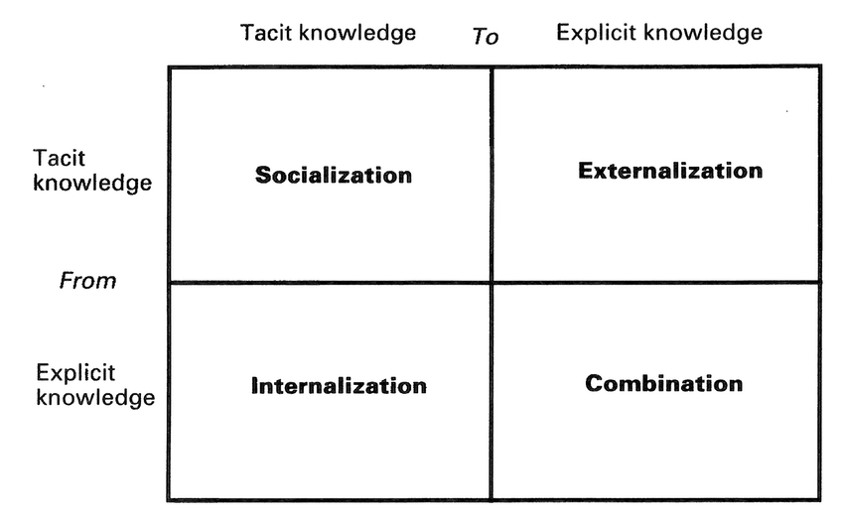

#### Figure: 2. Knowledge conversion Nonaka (1994)

Knowledge conversion is explained by Nonaka in 1994 as follows:

**2.4.4.1 Form tacit to tacit (socialization)**

Tacit to tacit knowledge transmission is very important for higher learning as it helps to learn and provides more encouragement for knowledge-making and life-long learning. Advanced learning institution leaders thus need to hug and foster the dynamism of knowledge creation by providing a conducive atmosphere for tacit to tacit knowledge creation and transfer. Currently, most of them are working the traditional way of creating and sharing tacit knowledge in a formal environment, which limits the ability to capture such knowledge. According to the SECI model, which was created by Nonaka (Nonaka, 1996) (socialization, externalization, combination, and internalization), tacit to tacit knowledge is best shared through the socialization process. Although he mentions the process of socialization, he fails to explain the process in detail or the environment conducive for socialization.

**2.4.4.2 Form explicit to explicit (Internalization)**

Explicit knowledge is codified information and data that are written down and may be easily understood and decoded by the recipient. Explicit knowledge sometimes is often expressed in very formal writing and wishes a particular level of education to be so readily understood. Explicit knowledge is typically documented as words, numbers, and codes; and it is often printed, transferred, or stored as media. Different sorts of explicit knowledge include; manuals, copyrights, patents, scientific formulas, musical notes, and mathematical expressions.

**2.4.4.3 Form Tacit to explicit (Combination)**

People possess slightly different types of tacit and explicit information and apply their knowledge in distinctive ways in which. people use different views to have faith in issues and devise solutions. They share information and cluster physical and intellectual assets in new and artistic ways (Ashkenas et al., 1998). Comparing tacit and explicit types of knowledge is a way to think, not to point out differences.

## 2.4.5 Understand of Knowledge Management

KM is concerning creating proper knowledge and provide for the right people. It's concerning making sure that a corporation will learn, which it'll be able to retrieve and use its data assets in current applications as they're required. within the words of Peter Drucker, it's "the coordination and exploitation of organizational knowledge resources, to create benefit and competitive advantage" (Drucker 1999, Hull, Coombs, & Peltu, 2000).

Where the disagreement sometimes happens related to the creation of new knowledge. Wellman (2009) limits the scope of knowledge management to lessons learned and the techniques employed for the management of what is already known. He said that knowledge creation is often perceived as a sperate discipline and generally falls under innovation management.

Based on (Bukowiz and Williams, 1999) connect KN directly to tactical and strategic demand. Its focus is on the use and improvement of knowledge-based property to enable the firm to answer to the issues. Based on this idea, the answer to the question “What is knowledge management” would be seriously broader. Likewise, another definition is presented by Davenport & Prusak (2000), which mention that KN "is managing the corporation's knowledge through a systematically and organizationally specified process for acquiring, organizing, sustaining, applying, sharing and renewing both the tacit and explicit knowledge of employees to enhance organizational performance and create value."

According to the argument in the above, we can say that the exact definition of knowledge management is as follows:

*Knowledge management is the systematic management of an organization's knowledge assets to create value and meet tactical & strategic requirements; it consists of the initiatives, processes, strategies, and systems that sustain and enhance the storage, assessment, sharing, refinement, and creation of knowledge*.

That is why knowledge management involves a strong companies goal and objective, and it involves the management of knowledge that is helpful to create value for the organizations.

Knowledge management is critical because it improves the efficiency of an organization’s decision-making ability. Making sure that all employees have access to the entire information. Transformation is easier within the organization, clients benefit from enhancing access to best practices and employee turnover reduces.

## 2.4.6 Knowledge management activities

Many kinds of literature have identified knowledge identification, knowledge acquisition, knowledge application, knowledge sharing, knowledge development, knowledge creation, knowledge preservation, and knowledge measurement as knowledge management activities in an organization.

### **Knowledge Identification**

An enterprise should public its business strategies and objective. The knowledge needs to be identified to meet theses all the above goals. The distinction between what the enterprise requires and what it currently has is what is called is the knowledge gap.

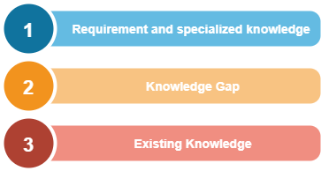

#### Figure: 2. Schema of Individual Knowledge Needs

The above figure identifies the knowledge gap of individual employees.

### **Knowledge Acquisition**

After recognizing the knowledge gap the next action is to close the knowledge gap by applying knowledge acquisition or knowledge import. Organization import a solid part of their knowledge from outside sources. A good relationship with clients, suppliers, and other partners, it’s significant to provide knowledge for your company through other people.

Knowledge acquisition is simply the process of achieving knowledge that is available somewhere, for an organization this could be very easy to achieve the knowledge through an existing document.

### **Knowledge Application**

After achieving knowledge, knowledge should be applied in a company or organization, knowledge application means making knowledge profoundly active and relevant for an organization in creating values. Knowledge application deals with the employees continually apply their knowledge to their working situation.

### **Knowledge sharing**

After applying the knowledge in an organization, the next step is knowledge sharing. The sharing and distribution of knowledge within a corporation are an important precondition for turning isolated information or experiences into something which the entire organization can use. the foremost important step is to research the transition of data from the individual to a group or organization. In a knowledge-based economy, knowledge itself isn't power, when knowledge is shared, it becomes power.

### **Knowledge Development**

Knowledge development is a structure that complements knowledge acquisition. It concentrates on generating new skills, new technologies, better ideas, and effective process. Knowledge development covers all management efforts and aimed at generating capabilities that are not yet implemented in the organization.

### **Knowledge Creation**

Knowledge creation is the key focus on creating new knowledge and new technology or innovating the current knowledge of the companies. Nonaka and Takeuchi 1995, suggested a knowledge management model in terms of knowledge creation perspectives based on four types of process knowledge conversions. The spiral type conversions between explicit knowledge and tacit knowledge, for instance, the SECI model are as follows:

* from tacit knowledge to tacit knowledge (Socialization)
* from tacit knowledge to explicit knowledge (Externalization)
* from explicit knowledge to explicit knowledge (Combination)
* from explicit knowledge to tacit knowledge (Internalization)

### **Knowledge preservation**

Preservation is the activity of keeping something from loss or danger. The selective of maintaining information, document, and experience require management, the process of selecting, storing, and regularly updating knowledge of potential future value must be carefully structured.

### **Knowledge Measurement**

The next stage of knowledge management is the activity, this is to measure the impact and effect after implementing knowledge management in an organization such as customer satisfaction, efficiency productivity, quality, and other activity. These form the backbone of knowledge management processes as they outline all aspects involved in the actual management of knowledge.

## 2.4.7 Benefits of knowledge management

Knowledge is a powerful property, knowledge can be organized, manipulated, and communicated, organizations can achieve several advantages via knowledge management (Davenport and Prusak, 1998). The power and benefits of knowledge and its management can be understood through individual and organizational learning processes.

On the other hand, knowledge management is a systematic method of capturing and utilizing business collective information to create value. The potential blessings of effective understanding control are full-size as with most processes, there are certain challenges to consider. Some of the benefits of knowledge management are:

* Improved organizational agility
* Better and faster decision making
* Quicker problem solving
* Increased rate of innovation
* Supported employee growth and development
* Sharing of specialist expertise
* Better communication
* Improved business process

Indeed, there are lots of other benefits to knowledge management but these are the core benefits which we achieve in the very first stage, and a good knowledge management system will make it very easy to find and reuse relevant information and resources around our business. By implementing the following our business would be improved:

* create better products and services
* develop better strategies
* improve profitability
* reuse existing skills and expertise
* increase operational efficiency and staff productivity
* recognize market trends early and gain an advantage over your rivals
* benchmark against your competitors
* make the most of your collective intellectual capital

The resourceful collaboration will bring greater views, numerous reviews, and sundry stories to the procedure of decision-making, helping your enterprise to make decisions based on collective knowledge and expertise.

## 2.4.8 Understanding knowledge management system

In common, Knowledge Management Systems (KMS) is IT that enables businesses to manage powerful and green knowledge. Some definition of KMS has been proposed by some researchers. In this study, we use the KMS definition by *Alavi and Leidner.* The knowledge management system can be defined as a class of information systems and managing companies' knowledge. In a nutshell knowledge management system would not have differences from other information systems, instead of content and activities by users. The knowledge management system would consist of hardware, software, people, and organization environment around it.

For a better understanding of the knowledge management system first, we should understand the characteristics of KMS, **table 1.2** as Maier and Hadrich propose a characteristic of KMS, comprise of goal, processes, large platform, advanced knowledge, knowledge services, knowledge instrument, specific knowledge, and participants.

#### Table 1.2 Characteristics of KMS (Maier and Hadrich, 2006)

|  |  |
| --- | --- |
| KMS Characteristics Component | Explanation of Component |
| Goal | * Bring knowledge from the past to bear on present activities, thus resulting in increasing levels of organizational effectiveness (Lewis and Minton (1998); Stein and Zwass (1995). * As the technological part of the KM initiative that also comprises person-oriented and organizational instruments targeted at improving the productivity of knowledge work (Maier (2004)) |
| Processes | * Developed to support and enhance knowledge-intensive task, processes, or projects (Detlor, 2002); Jennex and Olfmann (2003)) * Supported knowledge processes such as knowledge creation, organization, storage, retrieval, transfer, refinement, and packaging, (re) use, revision, and feedback, also called the knowledge life cycle, ultimately to support knowledge work (Davenport et al. (1996)) |
| Comprehensive Platform | * KMS is not an application system targeted at a single KM initiative, but a platform that can be used either as IT to support knowledge processes or integrating base system and repository in which KM application systems are built (Maier (2006)) * There are two platform categories, the first user-centric approach with a focus on processes, and ITcentric approach which focuses on the base system to capture and distribute knowledge (Jennex and Olfman (2003)) |
| Advanced Knowledge Services | * KMS are ICT platform consist of several integrated services * Basic services such as collaboration, workflow management, document and content management, visualization, search and retrieval (Seifried and Eppler (2000)) |
| Knowledge Instruments | * KMS are applied in a large number application area (Tsui, 2003) * KMS especially support KM instruments (Alavi and Leidner (2001); McDermott (1999); Tsui (2003)) * KMS offers targeted combination and integration of knowledge services that together foster one or more KM instruments (Maier, 2006) |
| Specifics of Knowledge | * KMS helps to assimilate access to sources of knowledge, and with the help of shared context, increase the breadth of knowledge sharing between persons rather than storing knowledge itself (Alavi and Leidner (2001)) |
| Participants | * Users play roles of active, involved participants in the knowledge network forested by KMS (Maier, 2006)) |

# **2.5 Human Resources Management (HRM)**

For more than a century now human resources as a discipline and practice in the management of human beings in an organization have evolved and developed into exceptional areas. These order practices have gone through a process of trial and mistake theory building and testing of different concepts by practicing managers and academics (Farnham & Pimlott 1979; Storey 1989; Armstrong 1995).

The underlying forces behind the evaluation and development of human resource management have been (and nonetheless are) especially environmental, and the quest for the know-how of better ways of acquiring and utilizing labor.

Based on (Armstrong, 2006) human resource management (HRM) is defined as a strategic and coherent approach to the management of the organization’s most valued assets, the people working there who individually and collectively contribute to the achievement of its goal. With this definition, we can understand that (HRM) or basically (HR) is a function in organizations designed to maximize employee activities, performance in service of their organization's strategic goal on policies and systems (Collings & Wood 2009).

HR departments and units in organizations are responsible for the various number of activities, including employee hiring, training and development, performance, assessment, and rewarding like managing pay and benefits systems (Paauwe & Boon, 2009).

# **2.6 Method of data collecting**

The method used by the author in the process of collecting data, the processes are as follows:

## 2.6.1 Observation

Observation is a method of data collection in which researchers observe within specific research. These observations are made by looking at A.S Private High School, which is located in Afghanistan / Kabul / Darul Aman / postcode 1004. On another hand, it provides a chance to learn things that students and student families may unwilling to discuss in an interview.

This observation took place from January 2020 to August 2020.

## 2.6.2 Literature review

A.S Private High School, decide to develop a student management system, nowadays school needs to manage more information than ever before. Without a good internal infrastructure for students, teachers, managers, headmaster to share data critical school and information will be lost, or even a bad leading of problems that can affect the school. To keep the competitive stage school requires a simple solution that runs as an individual function, and connect their entire operation and use it as a key communication tool.

## 2.6.3 Interview

As I mentioned in the background We were not able to meet face to face, because of COVID-19 as well as the way, A.S Private High School is located in Afghanistan and this thesis was held in Indonesia.

We had several WhatsApp calls with the manager of the school, and he provided us enough information about the school for more see appendix I

# **2.7 Rapid application development method (RAD)**

Rapid application development (RAD) looks to become the first topical with the publication for a text by James Martin with the same title (Martin, 1992). The inventor of ARD, Martin defines the key objectives of RAD as high-quality systems, fast development, and delivery and low costs. These aims can be summarized up in one sentence, the trade needs to deliver working business applications in a shorter timescale and for less investment.

RAD has been explained in more detail in practitioner circles, but there looks to be very little academic material assessing RAD. This is not a big deal in the context of a systematic survey of the existing literature on information system development methodologies (ISDMs) conducted by Wynkoop and Russo (Wynekoop and Russo, 1997).

Numerous people see the RAD as a complete approach to information systems development in that it covers the whole life cycle, from initiation through to delivery.

There are several methods available for RAD such as Martin and more recently in the UK the dynamic systems development method dynamic system development method (DSDM).

## 2.7.1 Key benefits of RAD

1. Improve flexibility and adaptability as developers can make adjustments quickly during the development process.
2. Fast iteration, decrease development time and speeds up delivery.
3. Encouragement of code reuse, which means less manual coding, less room for error, and shorter testing times.
4. Enhance client satisfaction due to high-level collection and coordination between stakeholders (developers, clients, and end-users).
5. Fewer surprises as, unlike the Waterfall method, RAD includes integrations early on in the software development process.

## 2.7.2 RAD stages

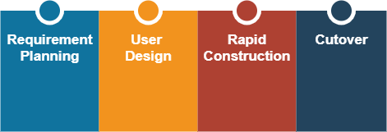

#### Figure: 2. RAD stages

### **Stage Requirements planning**

The first stage requirements planning is similar to a project scoping meeting, although the planning stage is condensed compared to other project management methodologies, this is a critical step for the ultimate success of the project. During this stage developers, customers (software users), and team members communicate to determine the goals and expectations for the project as well as existing issues that would need to be addressed during the build.

Here is a very basic breakdown of this stage:

1. Finding the current problem.
2. Defining the requirements for the project.
3. Finalizing the requirements with every stakeholder's approval.

### **Stage User Design**

This stage is focusing on development and building the user design, once the project scoped out we should start building the design for the user, this the RAD’s methodology and what sets it apart from other project management strategies. During this stage customers or clients should help the developer met their requirements. And this method allows developers to tweak the model as they go until they reach a satisfactory design. Both sides the software developers and clients learn from the experience to make users there is everything works perfect no error is peaking.

### **Stage Rapid construction**

The third stage takes the prototypes and beta systems from the design stage and changes them into the working model. Because almost the majority of the problems and changes were addressed during the iterative design stage, developers can build the last and final working model more quickly than they could by following a traditional project management approach.

Here are the breakdown steps:

1. Planning for rapid construction.
2. Program and application development.
3. Coding.
4. Unit, integration, and system testing.

The software development team, programmers, coders, testers, and developers work together during this stage to make sure everything is working smoothly and that the result satisfied the client's expectations and objectives.

This stage important because the users get to give inputs throughout the process, they can suggest alterations, changes, or even new ideas that can solve problems as they arise.

### **Stage Cutover**

This is the implementation stage where the output of our product will be launch. It contains data transformation, testing, and changeover the new system.

## 2.7.3 Strengths and weakness of RAD

RAD has advantages and disadvantages as a methodology application development. Some advantages of using the method RAD is as follows (Shalahuddin and Rosa, 2011):

1. The shipping process is easier; this is because of the process of making more uses script pieces
2. Easy to observe because it uses a prototype model, so users understand more about the system being developed.
3. More flexible because developers can do the design process repeat at the same time
4. User involvement is increasing because it is apart from the team as a whole.
5. Speed ​​up overall system development time because it tends to ignore quality.
6. A more standard and comfortable appearance with help *supporting software.*

# **2.8 SDLC (System Development Life Cycle)**

## 2.8.1 Definition SDLC

The systems development life cycle (SDLC) is a theoretical model used in project organization that describes the phases involved in an information system development project, from an initial possibility study over maintenance of the completed application. Software development life cycle (SDLC) could be a technique by that the computer code is developed during a systematic manner and which will increase the likelihood of finishing the computer code project inside the time point in time and maintaining the standard of the wares as per the quality. The System Development Life Cycle framework provides a sequence of activities for system designers and developers to follow for developing computer code. (Klopper, R., Gruner, S., & Kourie, D. 2007).

## 2.8.2 SDLC Phases Model

These phases generally demonstrate in every software development life cycle model; the models are as follows:

1. Understanding the problem (through requirements gathering)
2. Deciding a plan for a solution (Design)
3. Coding the planned solution
4. Testing the actual program
5. Deployment & maintenance of the product

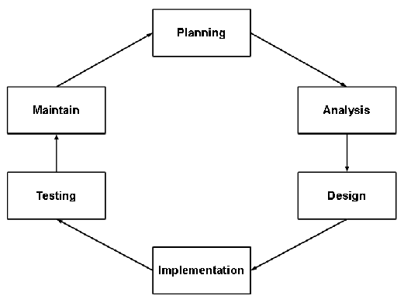

#### Figure: 2. SDLC Phases Model

On the other hand, activities performed during software development, some activities are performed after the main development is done, sometime there will be an installation stage which is connecting with actually installing the system on the client's computer systems and then testing it.

# **2.9 Prototyping**

## 2.9.1 Understanding of Prototyping

A feature of RAD is the construction of the prototype to jumpstart design and building out client requirements. The goal is to build a feature light version of the finished product as of concept for the client, but more importantly, severs as a talking point a tool for clarifying requirements.

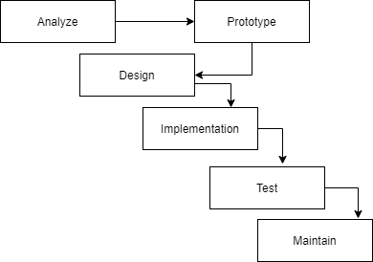

#### Figure: 2. Prototype model process

On the other hand, the prototyping model is a technique for quickly building a function but a complete model of the information system. There is various type of prototypes all of them intend to decrease the risk by building a quick and dirty replacement of a mockup of the intended system.

## 2.9.2 Advantages of prototype

1. Decrease development time
2. Decrease development costs
3. Needs user involvement
4. Developers receive quantifiable user feedback
5. Facilitate system implementation since users know what to expect
6. Results in higher user satisfaction
7. Exposes developers to potential future system improvement

# **2.10 System Testing**

## 2.10.1 Black-box testing

Software testing is the most often used technique for verifying and validating the quality of software. Software testing is the procedure of executing a program or system with the intent of finding faults. It is measured to be labor-intensive and expensive, which accounts for > 50 % of the total cost of software development. Software testing is a significant activity of the software development life cycle (SDLC).

It helps in developing the self-confidence of a developer that a program does what it is intended to do so. In other words, we can say it’s a process of executing a program with intends to find errors (Biswal et al. 2010). In the language of Verification and Validation (V&V), black-box testing is often used for validation (i.e. are we building the right software?), and white box testing is often used for verification (i.e. are we building the software right?). This study emphasizes the need to investigate various testing techniques in the software testing field, we have conducted a literature review to achieve reviews from state-of-art.

## 2.10.2 White-box testing

White-box testing is mostly used for discovering logical errors in the program code. It is used for fixing code, discovery random typographical errors, and uncovering incorrect programming assumptions. White-box testing is done at low-level design and implementable code. It can be applied at all levels of system development especially Unit, system, and integration testing. White box testing can be used for other development artifacts like requirements analysis, designing, and test cases. (S. Noikajana and T. Suwannasart, 2008)

# **2.11 Unified Modeling Language (UML)**

Unified modeling language (UML) is consistent and general-purpose modeling in the field of object-oriented software engineering. UML itself also provides the standard for writing a blue system print, which includes the concept of business processes, writing classes in the specific program language, database schema, and components needed in the software system.

UML is one of the tools models for designing development object-oriented based software, UML as a language that provides vocabulary in order of writing words in 'MS Word' for communication purposes. A model language is a language that has vocabulary and concepts of writing arrangements and is physically presented from a system. UML is not only a visual programming language, but can also be directly connected to various languages programming, such as JAVA, C ++, Visual Basic, or even connected directly into an object-oriented database. The models we used in this thesis as follows:

* Use Case Diagram
* Activity Diagram
* Class Diagram
* Sequence Diagram

## 2.11.1 Use case diagram

A use case is a collection of interactions that delivers a valuable result to a user. A use case should realize a goal or objective of a user or a particular class of users. A more precise definition is given by Cockburn:

*A use case captures a contract between the stakeholders of a system about its behaviour. The use case describes the system’s behaviour under various conditions as the system responds to a request from one of its stakeholders, called the primary actor.*

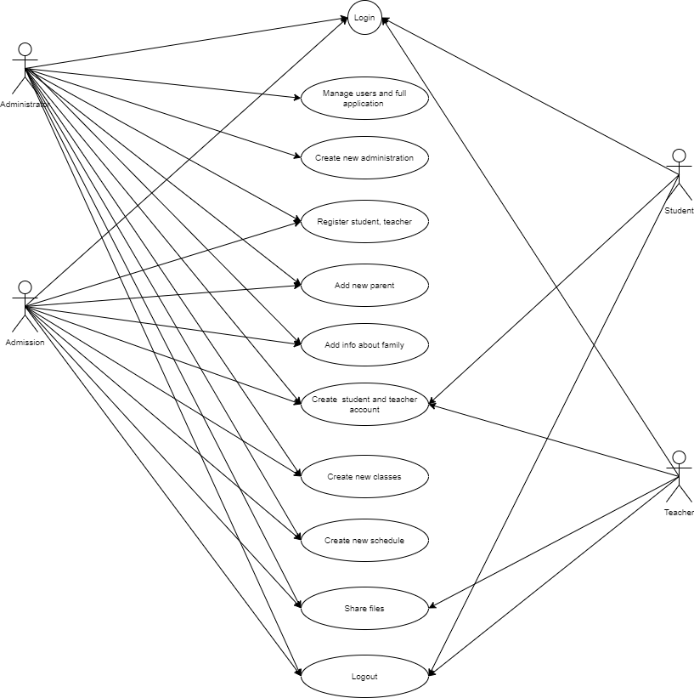

#### Figure: 2. Use Case Diagram

#### Table: 2. Properties of a use case

|  |  |
| --- | --- |
| Property | Definition |
| Actor | Party who obtains the observable result of the value of the use case, also known as the primary actor. An actor can be a person or another system. A use case can have supporting actors, i.e., other parties who contribute toward the execution of the process defined by the use case for the ultimate delivery of the service. |
| Association | An association is a relationship between an actor and a business use case |
| Generalizations | A relationship between actors to support the re-use of common properties. |
| Dependencies | Several dependency types between use cases are defined in UML. In particular, extend and include. Extend is used to include optional behavior from an extending use case in an extended use case. |

## 2.11 2 Activity Diagram

UML activity diagram describes the sequential or concurrent control flow among activities. The activity diagram can be used to modal the dynamic parts of a group of objects or the control flow of and operation. The activity diagram emphasizes the activities of the object so it is the best one to describe the realization of the operation in the design phase and describe the sequence of the activities (Ivar Jackobson, 1992).

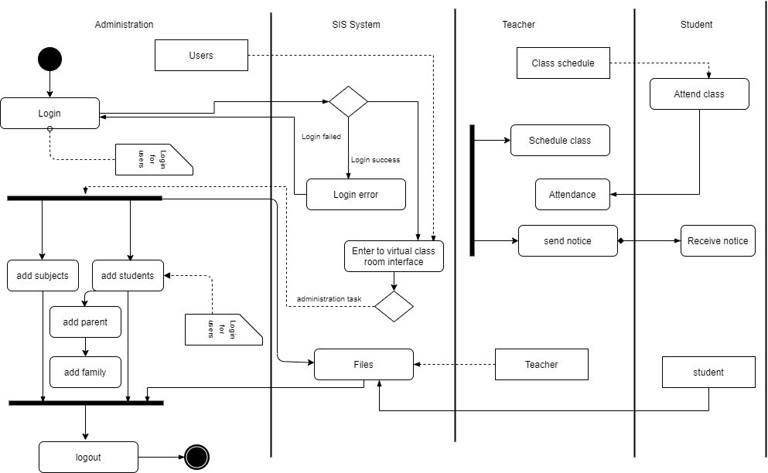

#### Figure: 2. Manage users and full application

## 2.11.3 Class Diagram

A UML class diagram shows static aspects of a system in terms of the classes of objects within the system, relationships between these classes, and constraints on the relationships. Associations represent relationships between classes. Classes are often further classified in terms of generalizations. Syntactically, a UML class diagram may be a collection of those class constructs. during this section, we offer a particular description for the syntactic structure of sophistication constructs in UML like class, association, association class, and generalization and therefore the static semantics of those class constructs. Based on this description, class diagrams are formally described (Munchen. 1998).

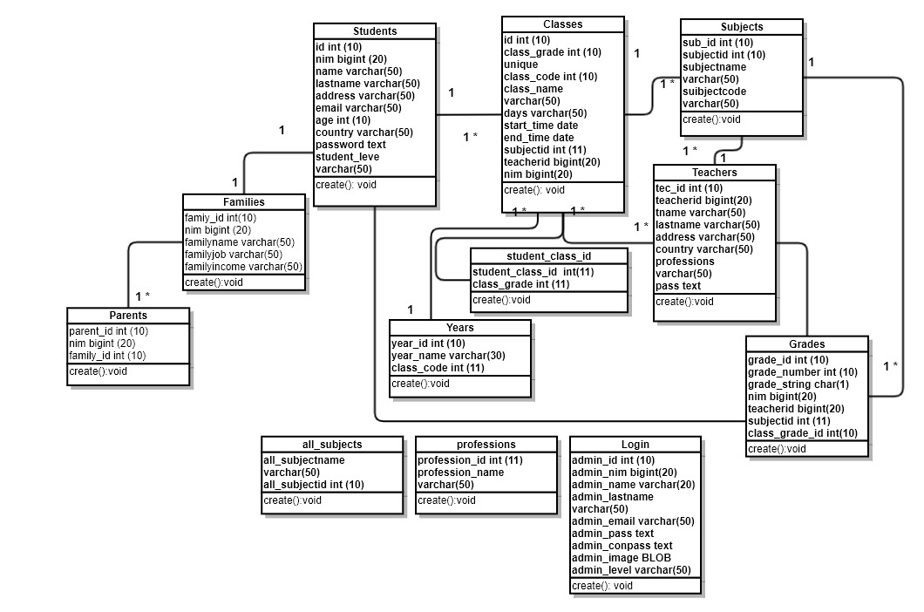

#### Figure: 2. Class Diagram

## 2.11.4 Sequence Diagram

Sequence diagrams illustrate the behavior of objects in the use case by describing the lifetime of the object and the message sent and received between objects. Therefore, for describing sequence diagrams, objects must be known involved in a use case and its methods the class instantiated into that object (Munchen. 1998).

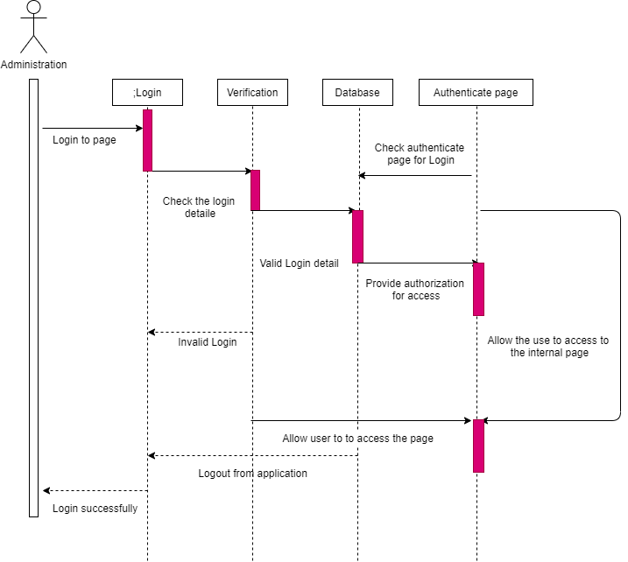

#### Figure: 2. Administration Sequence diagram

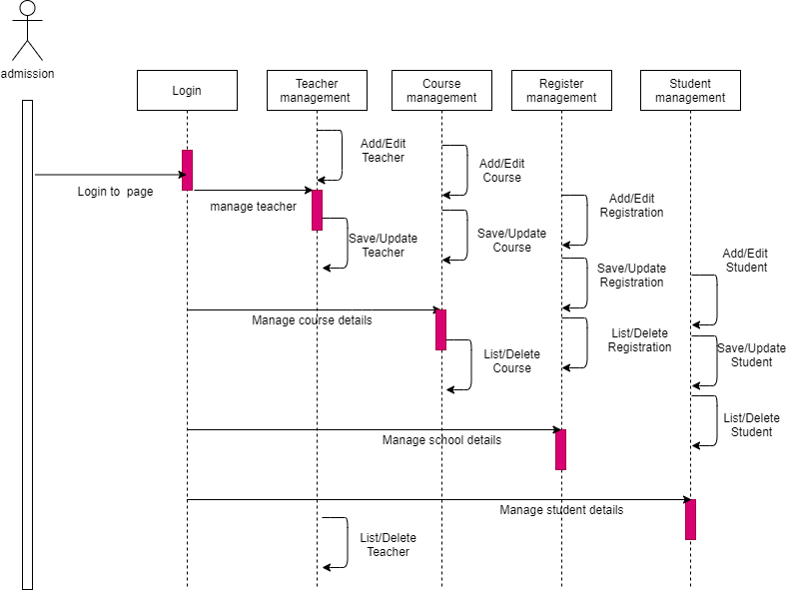

#### Figure: 2. Admission Sequence Diagram

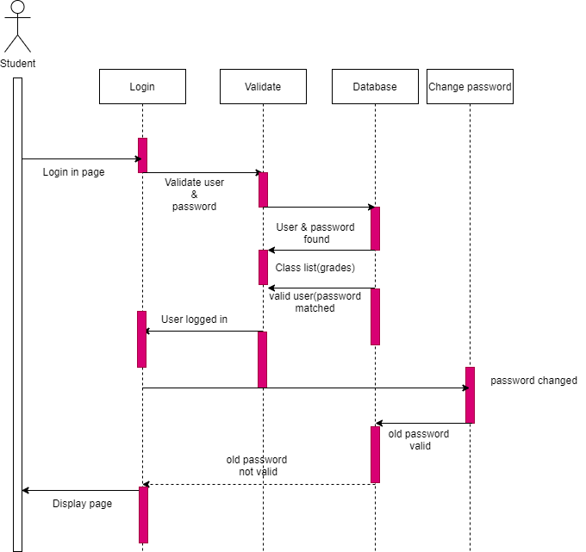

#### Figure: 2. Student Sequence Diagram

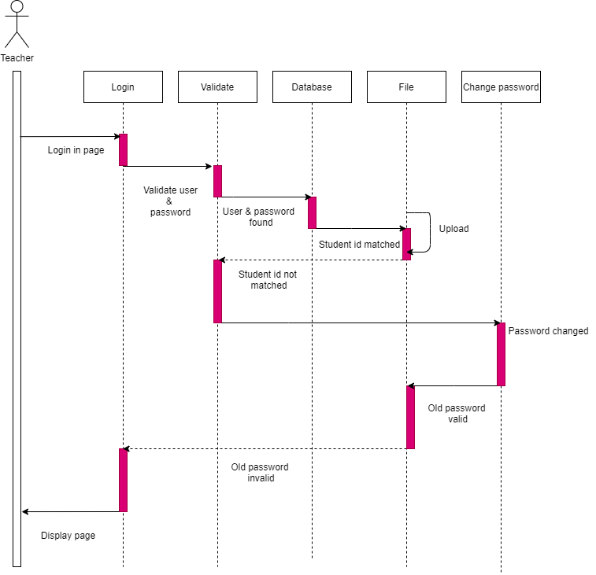

#### Figure: 2. Teacher Sequence Diagram

# **2.12 Database Concepts**

## 2.12.1 Understanding of Database

A database is any logically coherent collection of data organized for storage and retrieval by computers, as a single, possibly large, repository of data that can be used simultaneously by multi-users. Databases provide a high level of structure for the collection of data.

The Database Management System (DBMS) is the software that interacts with the users, database applications, and the database. Among other things, the DBMS allows users to insert, update, delete, and retrieve data from the database. Having a central repository for all data and the data descriptions allows the DBMS to provide a general inquiry facility to this data, called a query language. The provision of a query language (such as SQL) alleviates the problems with earlier systems where the user has to work with a fixed set of queries or where there is a proliferation of database applications, giving major software management problems.

Some people use the term DBMS more generically to include functions and tools to help users develop database applications. With the functionality described above, the DBMS is an extremely powerful tool.

# **2.13 MySQL Database**

Data design is an important part of the appliance development cycle. By analogy, building an application is like building a house. Having the proper tools is vital, but we'd like a solid foundation, the info structure. However, producing an honest data structure is often a frightening challenge, the search for an ideal arrangement can lead us to new territories where many methods are available.

Data design for MySQL databases is both a science and an art, and there must be a good balance between the scientific and therefore the empiric aspects of the tactic. The scientific aspect refers to information technology (IT) principles, whereas the empiric facet is usually supported by intuitions and knowledge.

MySQL (*www.mysql.com*), launched in 1995, has become the most popular open-source database system. Virtually all web providers include MySQL as part of their hosting plan, often on the ubiquitous LAMP (Linux, Apache, MySQL, PHP) platform. Another root cause of MySQL's popularity has been the ongoing success of phpMyAdmin (*www.phpmyadmin.net*), a well-established MySQL web-based interface. Therefore, many websites use MySQL as their back-end data repository.

# **2.14 System Testing Tools**

## 2.14.1 PHP

Based on the official website of PHP: PHP (recursive acronym for PHP, Hypertext Preprocessor) is a widely-used open source general-purpose scripting language that is especially suited for web development and can be embedded into HTML. What distinguishes PHP from something like client-side JavaScript is that the code is executed on the server, generating HTML which is then sent to the client. The client would receive the results of running that script, but would not know what the underlying code was.

You can even configure your webserver to process all your HTML files with PHP, and then there's no way that users can tell what you have up your sleeve. The best things in using PHP are that it is extremely simple for a newcomer, but offers many advanced features for a professional programmer. Don't be afraid of reading the long list of PHP's features. You can jump in, in a short time, and start writing simple scripts in a few hours.

## 2.14.2 XAMMP and phpMyAdmin

PhpMyAdmin is free and open-source software that lets you handle the administration of MySQL over the web. You can easily manage the database through a graphic user interface known as phpMyAdmin in this case. phpMyAdmin is written in PHP and has gained a lot of popularity in terms of web-based MySQL management solution.

You can perform operations on MySQL via the phpMyAdmin user interface while you can still directly execute SQL queries. And it lets you carry out operations like editing, creating, dropping, amend MySQL database, alter fields, tables, indexes, etc. Which user should be given what privileges, you can manage that too. phpMyAdmin has huge multi-language community support.

# **2.15 Visual Studio Code**

Visual Studio Code combines the simplicity of a source code editor with powerful developer tooling, like IntelliSense code completion and debugging. First and foremost, it is an editor that gets out of your way. The delightfully frictionless edit-build-debug cycle means less time fiddling with your environment, and more time executing on your ideas. Visual Studio Code supports mac OS, Linux, and Windows - so you can hit the ground running, no matter the platform.



# **CHAPTER III**

# **RESEARCH METHODOLOGY**

# **3.1 Method data collecting**

In this research we have used several data collection methods to help us understand more about the student system, the collection of data is collected in the form of library, interview, and observation.

## 3.1.1 Observation

Observation is a method of data collection in which researchers observe within specific research. These observations are made by looking at A.S Private High School, which is located in Afghanistan / Kabul / Darul Aman / postcode 1004. On another hand, it provides a chance to learn things that students and student families may unwilling to discuss in an interview.

This observation took place from January 2020 to August 2020.

## 3.1.2 Interview

The interview was conducted by interviewing the owner of the school Muhammad Nadir and the manager of (A.S Private High School) Khatira, as I mentioned earlier we cannot meet face to face we set everything through WhatsApp. This interview conducted to obtain information regarding the specifications of user requirements that will be later in building a student management system and the constrain of what happens so that the student management system is needed at A.S Private High School.

## 2.1.3 Literature review

Researchers use a literature review for collecting data and information, it could be a book, similar research, similar journal, and internet sites. The similar research table below is a collection of similar research as a reference for literature study by researchers.

#### Table: 2. Comparative Study of Literature

|  |  |  |  |  |  |  |
| --- | --- | --- | --- | --- | --- | --- |
| NO | Name | Title | Explanation | Advantage | Disadvantage | Year |
| 1 | Amr Salah Hamed Ramadan Ali*, Ezzat Garras Khalil | Mobile Apps Based Management Information System Using Cloud Computing in E-marketing and E-learning | Mobile apps became very important to our daily life, especially in global marketing and education. Developer skills and modern technology environment play important roles to improve the function and quality of developed communication using mobile apps | The mobile app has become an important tool used in many applicants. The communications using the mobile revolution can reap big profits for the company and customer | Not supported for the old version | 2012 |

|  |  |  |  |  |  |  |
| --- | --- | --- | --- | --- | --- | --- |
| 2 | 1. Ira Mirawati 2. Jenny Ratna Suminar | Student Appreciation toward Online Learning Management System: | LMS devices create relationships between teachers and students on a reciprocal basis and may involve two directions participation. Furthermore, LMS guides the student and academic staff in producing a better learning environment | LMS will help educators to connect with students individually, to understand their learning needs | Although there mention no disadvantages, we assume some people do have good access to the internet. | 2009 |

|  |  |  |  |  |  |  |
| --- | --- | --- | --- | --- | --- | --- |
| 3 | Dirk K. F. Meijer* | Information: what do you mean? | This essay is based on the thesis that information is as fundamental as matter and energy in the fabric of reality, in other words: information is physical. | In modern physics, quantum mechanics is an essential instrument | It's difficult to achieve a clean data | 2012 |

|  |  |  |  |  |  |  |
| --- | --- | --- | --- | --- | --- | --- |
| 4 | Drucker | Knowledge management System and practice | KM is about making the right knowledge available to the right people. It is about making sure that an organization can learn, and that it will be able to retrieve and use its knowledge assets in current applications as they are needed | Due to the difficulty in effectively managing embedded knowledge, firms that succeed may enjoy a significant competitive advantage. | The problem could be during transferring and combining knowledge across the firm | 1999 |

|  |  |  |  |  |  |  |
| --- | --- | --- | --- | --- | --- | --- |
| 5 | Jingyuan Zhao | School knowledge management framework and strategies, The new perspective on teacher professional development | Teacher professional development means the self-education promoting activities of teachers and the learning process becoming teachers with efficiencies by participating in various further educations related to education fields to make constantly the knowledge, skills, and attitudes related with the basic knowledge, teaching, administration, teacher cooperation, service zeal promoted and developed | To enhance the professional development of teachers, the application of knowledge management is worthy of an attempt no matter for an individual teacher or school. | The tool may be too complex for the user to comprehend the system and requires much more money. | 17 November 2009 |

|  |  |  |  |  |  |  |
| --- | --- | --- | --- | --- | --- | --- |
| 6 | Armstrong | Fundamentals of human resource management | For more than a century now, human resource management, as a discipline and practice in the management of people in an organization, has evolved and developed into different areas. | It can use a mixture of training methods. - Gets a learner out of the normal work environment, allowing them to focus their attention on the learning. | Constrained by the needs of the business and cost: trainees and instructors have to get together each time you run an event away from their normal workplace. - Requires trained instructors. - Not necessarily available when learners need it most. - Needs the same entry-level for all learners. | 2006 |

|  |  |  |  |  |  |  |
| --- | --- | --- | --- | --- | --- | --- |
| 7 | Paul Beynon-Davies,  Hugh Mackay | Rapid application development (RAD): An empirical review | Rapid application development (RAD) is an approach to information systems (IS) development which is much discussed in the practitioner literature. However, there is comparatively little research data on this topic. | * Reduce development time. * Increases the reusability of components. * Quick initial reviews occur. | Need strong team and individual performances for identifying business requirements.  It requires highly skilled developers/designers. | 1997 |

|  |  |  |  |  |  |  |
| --- | --- | --- | --- | --- | --- | --- |
| 8 | Yaying Mary Chou Yeh, | The Implementation Of Knowledge Management System In Taiwan’s Higher Education | This paper examines the application of knowledge management systems (KMS) in a private college in Taiwan, which is facing administrative challenges and cutting-edge competition. The multi-perspective modeling approach is adopted | Organization culture can inhibit or enhance organizational change efforts in knowledge management initiatives | Many KM application experts recommend the multi-perspective modeling approach. | 2000 |

|  |  |  |  |  |  |  |
| --- | --- | --- | --- | --- | --- | --- |
| 9 | Karen Edge | Powerful public sector knowledge management, a school district example | benefits of public sector adoption of knowledge management include: improving organizational quality and efficiency (McAdam and Reid, 2001); reducing costs (McAdam and Reid, 2001); and, decreasing interagency fragmentation (Ardichvili et al., 2003). | The network initiative further extends this  growing  culture of collaboration by requiring all LCs to participate in networks with their peers from other schools. | One of the most significant challenges, from a knowledge management perspective, is the chronic lack of sophisticated technology in schools | 2005 |

Based on the table above there are several advantages of the system to be made by researchers namely:

1. Use the SECI model and core process analysis to analyze knowledge management
2. Using system design and database design for documenting the system
3. This system was built using the PHP programming language
4. For saving data we are using MySQL

# **3.2** **System development method**

In this thesis, we are using the Rapid Application Development (RAD) method

## 3.2.1 Requirement Planning

In this stage, the researchers do the planning of making a knowledge management system for the school that will be developed based on the student requirement, the result achieved throughout the meeting, manager with teachers and teachers with the student.

1. Register student of (A.S Private High School)
2. Each student of (A.S Private High School) should have an account
3. Each student of (A.S Private High School) should be able to check his/her grade
4. Each Teacher of (A.S Private High School) should have an account
5. All the system should be controlled by Admin

## 3.2.2 Design stage

At this stage, the design and improvements are made knowledge management system for (A.S Private High School) using Unified Modeling Language (UML) tools with the following stages:

1. Make use case diagram
2. Make an activity diagram
3. Make a sequence diagram
4. Make Database specification
5. Database schema planning
6. Make a class diagram
7. Database mapping
8. Matrix CRUD
9. Menu Structure design
10. User interface design (UI)

# **3.2.3 Implementation stage**

At this stage, the testing process of the knowledge management system is carried out for (A.S Private High School), the implementation is as follows:

1. Build a system using the PHP programming language, we are using pure PHP and MySQL as database
2. Test the system using black-box testing or behavioral testing, within this method, we would be able to find the errors, within black-box we don’t need our user to understand coding in another hand to be a programmer.

## 3.2.4 Reasons for using Rapid Application Development

The reason behind Rapid Application Development (RAD), it’s as follows:

1. Improve flexibility adaptability as programmers can make adjustments faster during the development process.
2. The quick iteration decreases development time and speeds up delivery.
3. Encouragement for code reuse, reduce the code writing, less error, and shorter testing time.
4. Improve client satisfaction due to high-level collaboration and coordination between stakeholders.
5. Decrease the rate of risk management as stakeholders can discuss and address code vulnerabilities while keeping development processing going.

There is much more reason behind the RAD method, these are the key reasons what we chose RAD methods.

## 3.2.5 Reasons for using Black-box testing

The reason behind using black-box testing (BBT) it’s as follows:

1. In the black-box testing, there is a validation test, where the system can be said to be successful if the functions are there in this system can be accordant what the user desired.
2. In the black-box testing does not take a long time, compare to white-box testing, using the white-box testing requires more time it has to check procedural from scratch and coding one by one to ensure that there will be no error in the system.
3. In the black-box testing, we can use a use case diagram and scenarios developed and analysis as a guideline, whether the output is in the same line of user expectations or not.
4. With black-box testing, users will run the application directly and the developers will note any input or action taken by the user.
5. With black-box testing, a tester purely checks the input and output of the software. The tester evaluates what system should perform rather than how it is a manual approach to testing.

# **3.3 Mind Mapping**

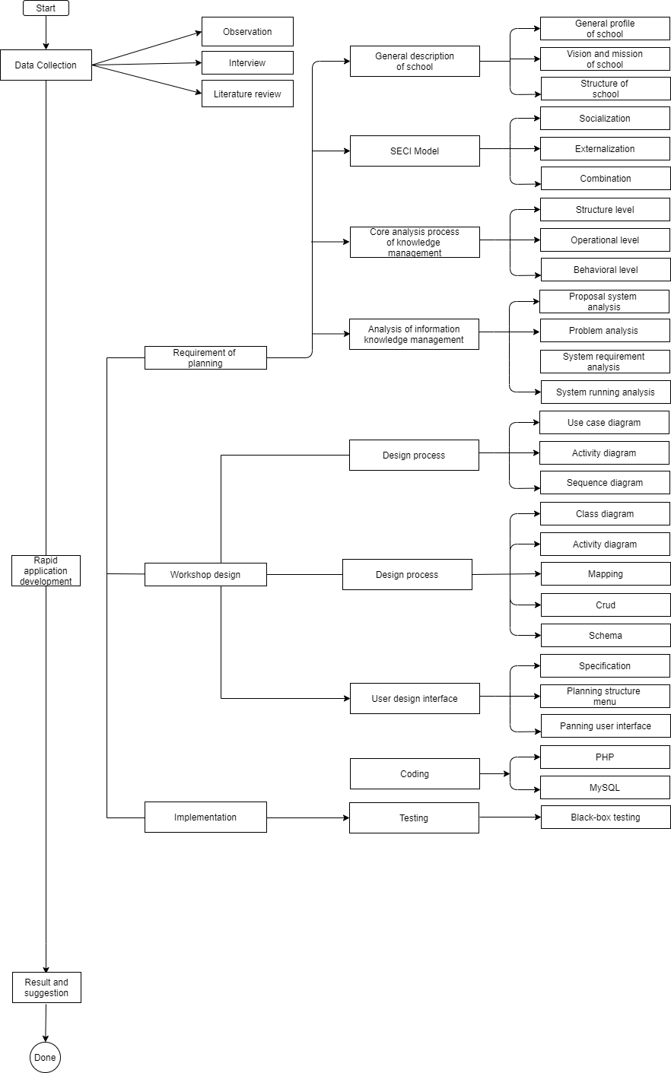

#### Figure: 3. Mind Mapping



# **CHAPTER IV**

# **SYSTEM ANALYSIS AND DESIGN**

# **Requirement Planning**

## 4.1.1 General description of A.S High School

### **4.1.1.1 Profile of A.S High School**

A.S Private High School. It is a private high school that was founded on January 1 of 2010, by Muhammad Nadir. As Afghanistan is an Islamic country, we believe in one Allah, and everything should be based on Islam according to the Afghanistan constitution. Hence, A. S private high school teaches Islamic subjects, besides that it provides computer learning, English learning, Math learning for beginner and advanced levels, and other usual subjects.

This private high school has five more branches around Kabul the capital of Afghanistan and one branch in Baghlan which is one of the northern provinces of Afghanistan. As I mentioned earlier, this private high school aims to provide learning facilities every winter they launch a course under the name of (Winter course), the subjects will be taught by expert teachers who have more than 10 years’ experience, for those who really cannot pay school will provide them free classes and give them a discount.

## 4.1.2 Vision, Mission, and Value of School

### **4.1.2.1 Vision**

We encourage you to learn new and exciting things with expert people and help your family by teaching them what you learn.

### **4.1.2.2 Mission**

1. Our mission is to provide high-quality education for our beloved children and youths.

2. We aim to provide safe learning with an inclusive environment.

3. Beyond our vision for each child and youths to develop and strengthen a curiosity of learning new knowledge

### **4.1.2.3 Value**

1. Be Good person

2. Be honest with your self

3. Treat everyone based on Islam

4. Stand with Al-Quran

5. Follow the Sunnah

6. Respect elders and be kind with children

7. Have curiosity for leaning

# **4.1.3 Logo of A.S Private High School**



#### Figure: 4. Logo A.S Private High School

# **4.1.4 Structure of A.S Private High School**

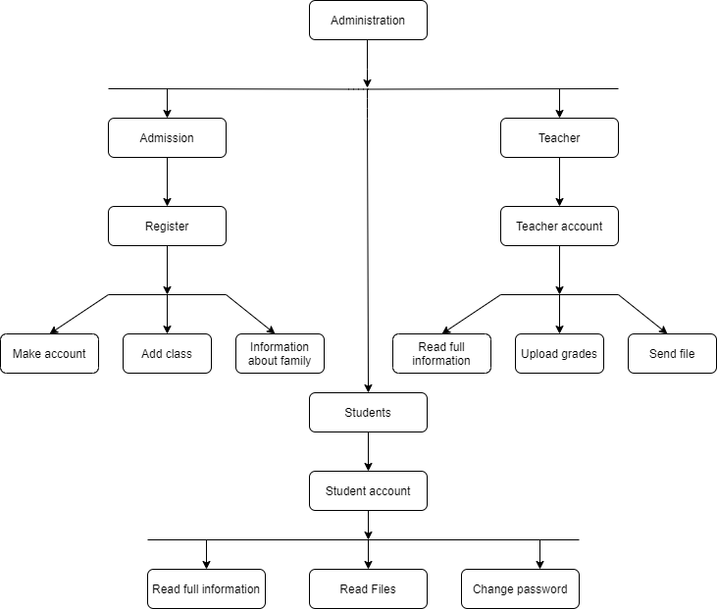

#### Figure: 4. Structure of A.S Private High School

## 4.1.5 Duties of A.S Private High School

Board: A primary responsibility of the school board is to ensure the best possible education experience for all students. This involves analyzing schedule and education programs and prioritizing how many should be spent.

Head: Heads of school are appointed by and are formally responsible to the board, the head will exercise his/her authority in consultation with the school executive, in consideration of a consensus of the school committee.

Load Study: The study load is based on the grade, as grade goes up, students achieve more subjects.

## 4.1.6 SECI Model

The SECI model is a well-known conceptual model that was first proposed by Nonaka (1991 and expanded by Nonaka and Takeuchi, 1995). It describes how explicit and tacit knowledge is generated, transferred, and recreated in organizations. While it was first proposed within the context of business organizations, the model can easily be applied to education, as explored by Lin, Lin, and Huang (2008) and Yeh, Huang, and Yeh (2011).

The SECI model consists of four modes of knowledge conversion: socialization (tacit to tacit), externalization (tacit to explicit), combination (explicit to explicit), and internalization (explicit to tacit).

### **4.1.6.1 Socialization**

Socialization, or tacit to tacit, it the process of converting new tacit knowledge through shared experiences in day to day social interaction.

### **4.1.6.2 Externalization**

Externalization, or tacit to explicit it is the process of share experiences from documentation such as meeting, discussion, documentation during customer visiting, and other types of forums.

### **4.1.6.3 Combination**

Combination, or explicit to explicit is a process because explicit knowledge is collected from inside or outside the organization and then combined, edited, or processed to form more complex and systematic explicit knowledge is then disseminated among the members of the organization.

### **4.1.6.4 Internalization**

Internalization or, tacit to explicit is a process because explicit knowledge creates and shared throughout an organization than convert into tacit knowledge by individuals.

## 4.1.7 Core Process Analysis

### **4.1.7.1 Knowledge Acquisition**

Knowledge acquisition refers to the knowledge that an organization tries to obtain from external sources. External knowledge sources are critical and one should, therefore, take a total view of the value chain.

### **4.1.7.2 Knowledge Development**

The knowledge development branch wants to improve the knowledge and capacities of the organization in the region. This can be done with the help of sharing ideas through the routine meeting.

### **4.1.7.3 Knowledge sharing**

Knowledge sharing can be described as either push or pull, knowledge sharing improves communication among employees and customers.

### **4.1.7.4 Knowledge Utilization**

Knowledge utilization is measure information pickup, processing, and application, information pickup means the process of retrieving or receiving information from the organization.

### **4.1.7.5 Knowledge Retention**

Knowledge retention involves capturing knowledge in the organization and that can be used later.

### **4.1.7.6 Knowledge Goals**

To capture knowledge - this goal can be gained by creating KM repositories.

To improve knowledge access – to facilitate the processes of knowledge transform between individual and between an organization

To improve the knowledge environment - by proactively facilitating and rewarding knowledge creation, transformation, and use.

To manage knowledge as an asset – some companies are leveraging their knowledge capital in the balance sheet, others are leveraging their knowledge assets to generate new income from or to reduce costs with their patents base.

## 4.1.8 Knowledge management analysis

### **4.1.8.1 Problem analysis**

This problem analysis is based on the background above, the problem identified as follows:

1. Not well administration, student information is not accurate, and the school does not have any information about the student’s family
2. Lack of knowledge possessed by several teachers of A.S Private High School, regarding student privacy, like student grade, student secret information accurate scheduling, and so on.
3. Lack of knowledge sharing, teachers cannot share their knowledge, most of them are in the state of tacit, which is not useful for other teachers.
4. Knowledge is only limited to certain divisions and is not yet published to the entire school, it demonstrates having a bad management system.
5. Putting documents separately makes lots of difficulties, especially when someone needs the file.

### **4.1.8.2 Component Diagram**

Details about school automation system component diagram:

Student component

Classes component

Registration component

Courses component

School component

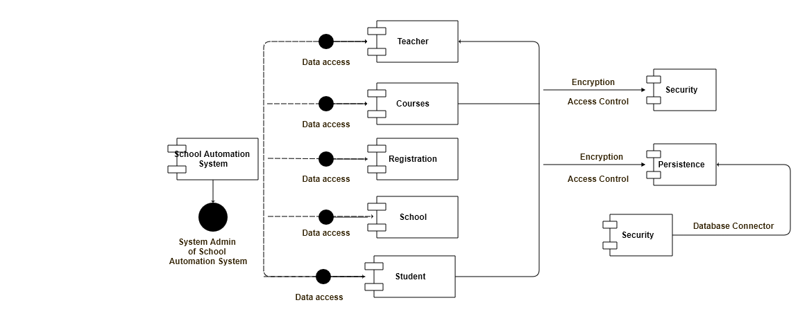

#### Figure: 4. Component Diagram of school

The school automation system data flow diagram is using as an introductory step to develop an overview of the entire school before going into more detail, which can later help, it consists of overall application dataflow and process of the school system.

### **4.1.8.3 Zero level Data flow diagram (Zero Level DFD)**

The zero levels of DFD of the school automation system, we have tried our best to cover the high-level process of school, it’s the overview of the entire school automation system.

We designed this process to show the registration and login to the system as a single high-level process, with its relationship to external entities of schools, students, and classes, now it should be easy to grasp by users easily.

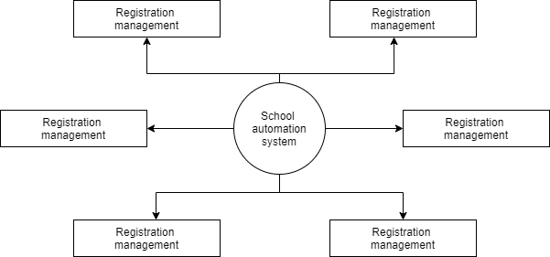

#### Figure: 4. Zero levels of DFD

High-level entities process flow of school automation system as follows:

* Managing all the school
* Managing all the Student
* Managing all the Classes
* Managing all the Teachers
* Managing all the Courses
* Managing all the Registration
* Managing all the Login

### 4.1.8.4 First level Data flow diagram (1st level DFD)

The first level of data flow diagram (DFD) school automation system shows the system is divided into sub-systems processes, each of which deals with one or more of the data flows to or from an external agent, and which together provide all of the functionality of the school automation system as entire. This also identifies internal data stores of login, registration, courses, teachers, classes, that must be present for the school to start its job.

Main entities and output of the first level of the data flow diagram (DFD) as follows:

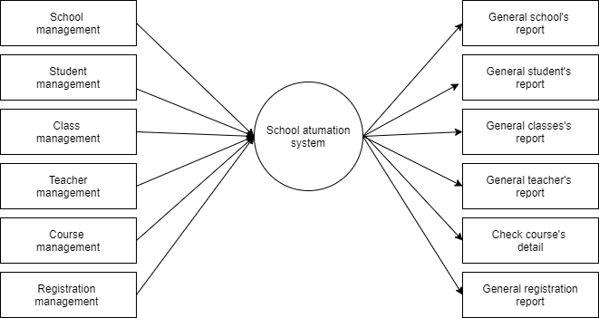

#### Figure: 4. First-level Of DFD

* Processing school records and generate reports of all schools
* Processing student’s records and generate reports of all students
* Processing Classes records and generates reports of all classes
* Processing teacher’s records and generates reports of all teachers
* Processing courses records and generates reports of all courses
* Processing registration records and generates reports of all registration
* Processing login records and generates reports of all logins

### **4.1.8.5 Second level data flow diagram (2nd level DFD)**

The second level goes one step deeper into parts level one of school, this level requires more functionality of school to reach the necessary level of details about the school activities and functionalities.

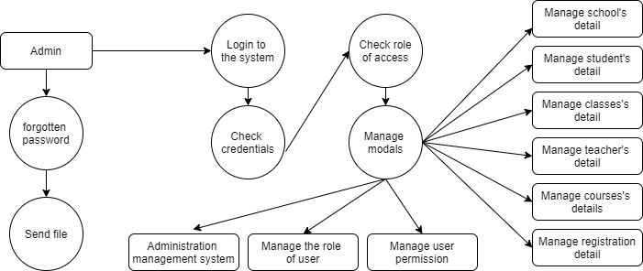

#### Figure: 4. Second-level of DFD

Low level of functionalities of School automation system as follows:

This level shows the admin functionality, admin can control the entire system, like add, edit, manage to add new admin, and so on.

### **4.1.8.6 Current Process**

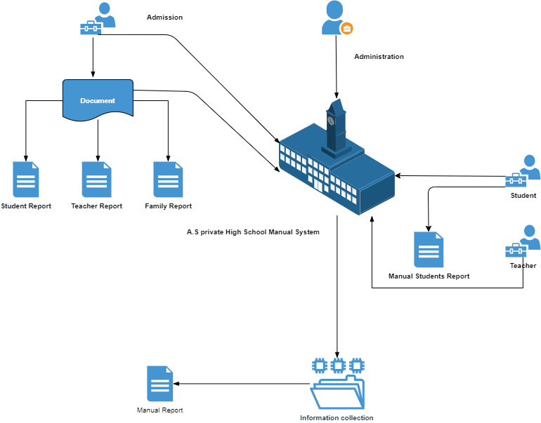

#### Figure: 4. Rich Picture Current Process

After analyzing the current system, the author found few problems, the problems are:

1. The current system is running manually, the data about student and teacher saving in a notebook.
2. It’s hard for a student to note the schedule because it’s still manual and written on the board and the teacher asks students to note it.
3. There is no privacy for a student, everyone knows each other grades, grading is one of the privacy of each student.
4. Lack of knowledge sharing, it’s hard for a teacher to share their knowledge as she/he wants to share it.

This system is consuming time, at the same its very expensive compare to the student management system, these are the core problem of A.S Private High School.

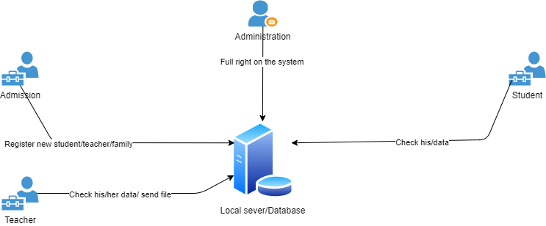

#### Figure: 4. Rich Picture Propose System

### **4.1.8.7 System Requirements Analysis**

1. Capable of knowledge document process
2. Capable of providing knowledge management facilities
3. Help user in sharing knowledge
4. Software:

* HTML
* CSS
* PHP
* MySQL
* Visual studio code, or any other editor

1. Hardware:

* Processor intel core i5
* RAM 4 BG or above
* Hard disk >200 GB
* Keyboard
* Mouse

### **4.1.8.8 Proposed System**

# **4.2 Design Workshop**

## 4.2.1 Use Case Diagram

Use case diagrams describe the relationship between actors and A.S Private High School.

1. Actor Identification

#### Table: 4. Actor Identification

|  |  |  |
| --- | --- | --- |
| No. | Actor | Description |
| 1. | Administration | This use case has the full right on the system, administration is the owner of the school as well |
| 2. | Admission | Admission, register new student, teacher, add classes, make the schedule, and make an account, admission is part of administration almost has the full right on the system. |
| 3. | Student | A student has only the right to read, the data on his/account and changes the password of his/her account |
| 4. | Teacher | A teacher has the right to read, write, and send including password change, all these done on his/her account |

1. Use Case Diagram Identification

#### Table: 4. Use Case Diagram Identification

|  |  |  |  |
| --- | --- | --- | --- |
| No. | Use case name | Description | Actor |
| 1 | Login | This is a general login, everyone who has the authority can get in through this login page | All Actors |
| 2 | Manage user and full application | This the administration area, where the entire system can be controlled. | Administration |
| 3 | Create new administration | This option is only allowed for administration, where the administration can add a new user administration for the school to control the system. | Administration |
| 4 | Register student, teacher | Every new and old system can be registered through this user, new users for enrolling to the school, old will be registered for the new academic year. | Admission |
| 5 | Add new parent | This is the information part where a student should provide full information about their parents, we made parents because we are using DBMS, relation database management system | Admission |
| 6 | Add info about family | The full information about a student’s family will be saved in this table | Admission |
| 7 | Create a Student and Teacher account | This is where a student or teacher achieve their accounts | Admission / admission |
| 8 | Create new classes | Create a new class for the student to study, and teacher to teach | Admission |
| 9 | Create a new schedule | Here student and teacher achieve their schedule, this can be during admission, or even after that can be added | Admission |
| 10 | Share files | Here a teacher can share files like, PNG, JPG, TXT, DOCS, XLSM, this option is available for administration as well | Teacher/ administration |
| 11 | Logout | Every user has to logout through one session, this session is available for everyone, after using the work logout. | All Actors |

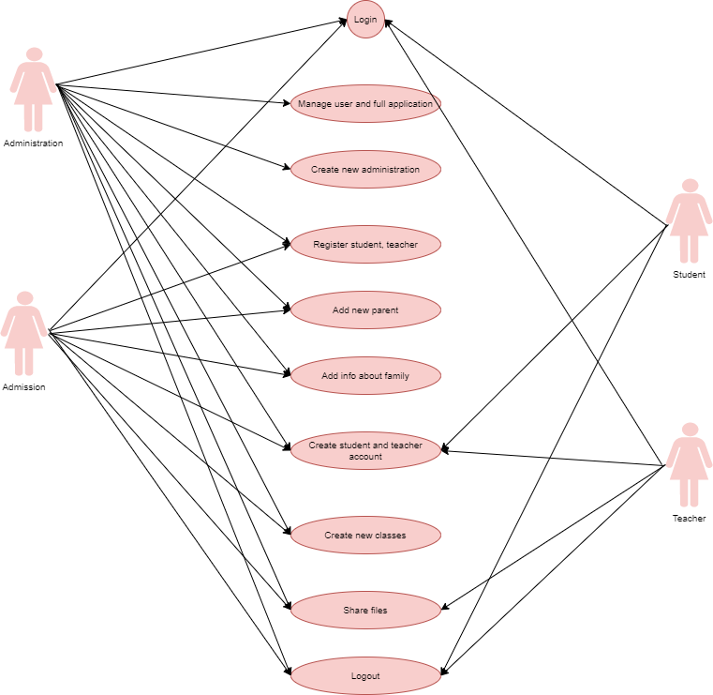

#### Figure: 4. Rich Picture of Use Case

1. Login

#### Table: 4. Login Narrative Diagram

|  |  |  |
| --- | --- | --- |
| Use case name | Login | |
| Use case id | 1 | |
| Actor | All Actors | |
| Description | This use case describes the login process | |
| Pre-condition | This use case shows how to login to the system, any user who wants to login have to be registered | |
| Trigger | After validation and user can open the system | |
| A typical course of the event | Actor Action | System Response |
| input username and password |  |
|  | Click login | System checks and validate |
|  | Display the related page |
| Alternative courses | If the user or password is the wrong redirect to the same page | |
| Conclusion | After validation actor can get in | |
| Post Condition | Successfully logged in based on the user level | |

1. Manage user and full application

#### Table: 4. Manage user and full application Narrative Diagram

|  |  |  |
| --- | --- | --- |
| Use case name | Manage users and full application | |
| Use case id | 2 | |
| Actor | Administration | |
| Pre-condition | The actor should have high authority in the school | |
| Trigger | After validation and user can open the system | |
| The typical course of the event | Actor Action | System Response |
| Open dashboard | View data, update, delete, delete, share files, change classes |
| - | - | Successfully updated |
| Alternative courses |  | |
| Conclusion | This user is for controlling the enter system | |
| Post Condition | Data has saved inside the database | |

1. Create new administration

#### Table: 4. Create new administration Narrative Diagram

|  |  |
| --- | --- |
| Use case name | Create new administration |
| Use case Id | 3 |
| Actor | Administration |
| Description | This actor should be part of the administration or the owner of the school |
| Pre-condition | Part of administration |
| Trigger | - |
| Alternative course | - |
| Conclusion | - |
| Post Condition | Redirect to the login page |

1. Register student, teacher

#### Table: 4. Register student, teacher Narrative Diagram

|  |  |  |
| --- | --- | --- |
| Use case name | Register student, teacher | |
| Use case Id | 4 | |
| Actor | Admission | |
| Description | This use case register student and teachers, here all data about a student and teacher will be asked, after collecting the data an account will be made for each student and teacher | |
| Pre-condition | - | |
| Trigger | - | |
| Typical courses of event | Actor Action | System Response |
| Click login | Display dashboard |
| See all information |  |
| Alternative  Courses | - | |
| Conclusion | - | |
| Post Condition | Successfully done activity | |

1. Add new parent

#### Table: 4. Add new parent Narrative Diagram

|  |  |  |
| --- | --- | --- |
| Use case name | Add new parent | |
| Use id | 5 | |
| Actor | Admission | |
| Description | The data about parent will be collected during the registration, and this can be done through the admission use case | |
| Pre- condition | Should have the admission authority | |
| Trigger | - | |
| Typical course of event | Actor Action | System response |
| Click login | Display the related page |
| Add information about the parent | |
| Alternative course | - | |
| Conclusion | - | |
| Post Condition | Successfully done activity | |

1. Add info about family

#### Table: 4. Add info about family Narrative Diagram

|  |  |  |
| --- | --- | --- |
| Use case name | Add info about family | |
| Use case id | 6 | |
| Actor | Admission | |
| Description | An admission use case can add data about student’s and teacher’s account | |
| Pre-condition | - | |
| Trigger | - | |
| Typical courses of event | Actor Action | System Response |
| Actor Action | System Response |
| Click login | Display new page |
| Add information about family | |
| Alternative  Course | - | |
| Conclusion | - | |
| Post Condition | Redirect to the login page | |

1. Create student and teacher account

#### Table: 4. Add info about family Narrative Diagram

|  |  |  |
| --- | --- | --- |
| Use case name | Create  student and teacher account | |
| Use case id | 7 | |
| Actor | Admission | |
| Description | This is where account made for student and teachers, and the account can be accessible right away | |
| Pre-condition | This use case should have the admission authority to make an account for student and teacher | |
| Trigger | - | |
| Typical course of event | Actor action | System response |
| Click login | Display the related page |
| Alternative course | - | |
| Conclusion | - | |
| Post Condition | Account successfully created | |

1. Create new classes

#### Table: 4. Create new classes Narrative Diagram

|  |  |  |
| --- | --- | --- |
| Use case name | Create new classes | |
| Use case id | 8 | |
| Actor | Admission | |
| Description | This is the responsibility of admission to make or add a new class for students as well as teachers. | |
| Pre-condition | Required the admission authority | |
| Trigger | - | |
| Typical course of event, alternative course | Actor action | System response |
| Click login | Display the related page |
| Conclusion | - | |
| Post Condition | Class successfully added | |

1. Create new schedule

#### Table: 4. Create new schedule Narrative Diagram

|  |  |  |
| --- | --- | --- |
| Use case name | Create new schedule | |
| Use case id | 9 | |
| Actor | Admission | |
| Description | This is the responsibility of admission to make or add a schedule for students and teachers. | |
| Pre-condition | Required the admission authority | |
| Trigger | - | |
| Typical course of event, alternative course | Actor action | System response |
| Click login | Display the related page |
| Conclusion | - | |
| Post Condition | Schedule successfully added | |

1. Share files

#### Table: 4. Share files Narrative Diagrams

|  |  |  |
| --- | --- | --- |
| Use case name | Share files | |
| Use case id | 10 | |
| Actor | Admission / teacher | |
| Description | This use case shares file with students, only teachers and admission can share files | |
| Pre-condition | Required the admission and teacher | |
| Trigger | - | |
| Typical course of event, alternative course | Actor action | System response |
| Click login | Display the related page |
| Conclusion | - | |
| Post Condition | Schedule successfully added | |

1. Logout

#### Table: 4. Logout Narrative Diagram

|  |  |  |
| --- | --- | --- |
| Use case name | Logout | |
| Use case id | 13 | |
| Actor | All actors | |
| Description | This is where all users should be logged out | |
| Pre-condition | Must be logged in | |
| Trigger | - | |
| Typical course of event, alternative course | Actor action | System response |
| Click login | Display the related page |
| Conclusion | - | |
| Post Condition | Redirect to the login page | |

## 4.2.2 Activity Diagram

The above diagram shows the activity of actors and roles of them, here a brief description of each. The diagrams as follows:

1. Login

This diagram shows the activities of the actor who holds the user and password, to login first user needs to put his/her username and after his/her password and press the login button if the password and user name its true system will display a new page with specific data for user holder, if not system will return you in the same page and display a message of “wrong password or username.”

This is a general login, where every user can get access through this the same login when a user puts his/her username and password system checks for validation and permission if the user has the admin authority system will open the admin dashboard if teacher user will open teacher page the same procedure is for students and admission. This login is safe with an encrypted password even a hacker gets access to our password still cannot do anything, because the hacker cannot read the password. We use the highest hash password in our system, the hash password is a functionality of the PHP programming language.

* 1. Login Activity Diagram

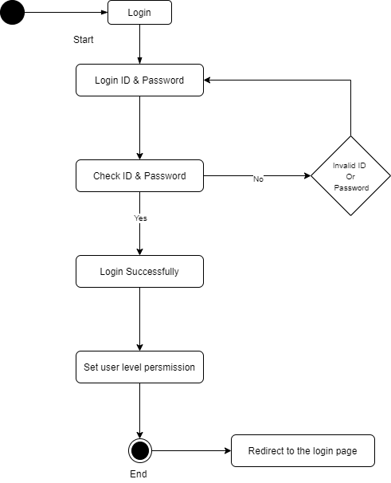

#### Figure: 4. Login Activity Diagram

* 1. Manage users and full application

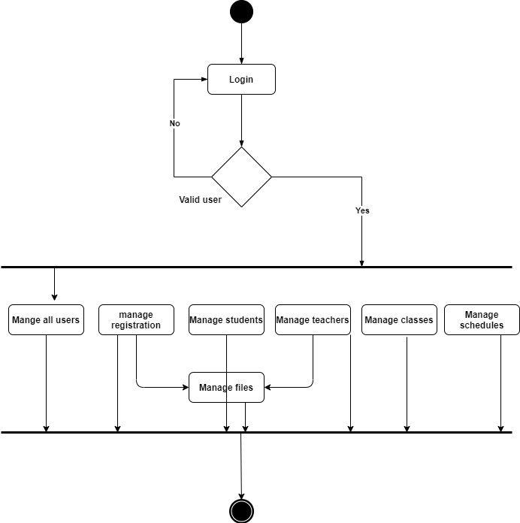

#### Figure: 4. Manage users and full application Activity diagram

In the above activity diagram, manage users and full application as the name implies it controls the entire system, and this user is allowed to add new administration user for the school, this user able to delete and update or even add new student, teacher on the system, this user can be controlled through the owner of the school or the one who has the high authority in the school.

* 1. Create new administration

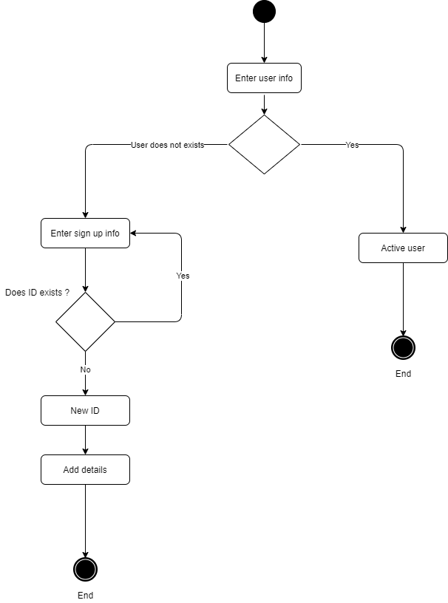

#### Figure: 4. Create new administration Activity Diagram

The above activity diagram shows how the system makes a new administration user, only the administration can make new administration, this user will be able to control the system, with this system we can access to the sensitive data.

* 1. Register student and teacher

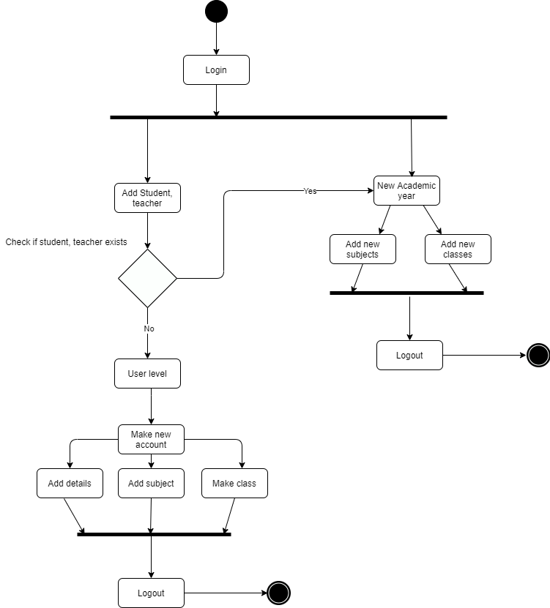

#### Figure: 4. Create student and teacher Activity Diagram

The above activity diagram shows how a student and teacher can be registered, student and teacher will be made based on the level within one user, this can be done with admission or either administration user, as I mentioned before admission is part of the administration of the school.

5. Add new parent

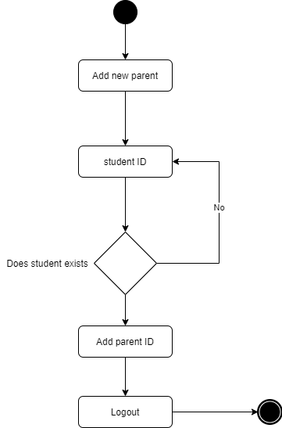

#### Figure: 4. Add new parent Activity Diagram

The above activity diagram shows how students related to a parent, we are using a relational database management system DBMS that’s why we made this table on our database although we could do this with only one table of the family, that is not good practice and design.

1. Add info about family

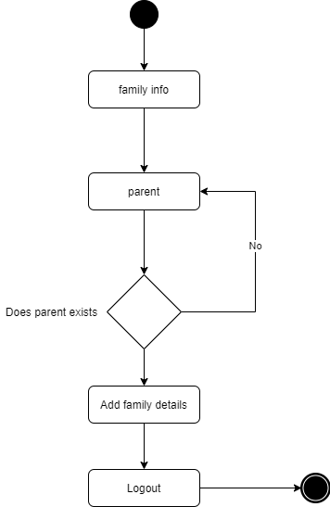

#### Figure: 4. Add info about family Activity Diagram

The above table shows adding information about the family, this table belongs to the parent, a student must have a parent’s ID to add complete details of the student’s family.

1. Create an account for the student, teacher

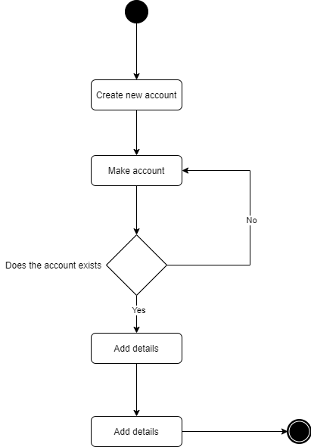

#### Figure: 4. Create an account for student and teacher

The above activity diagram shows how to student and teacher proceed, the only one who can make an account of student and teacher is admission and the owner of the school which is the administration.

1. Create new classes

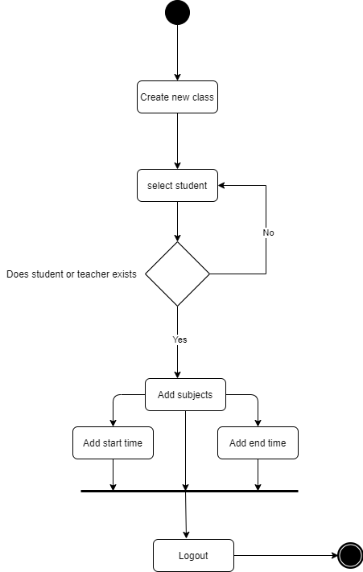

#### Figure: 4. Create new classes Activity Diagram

The above activity diagram shows how a new class is made, this activity diagram belongs to a teacher and student, admission has to add subjects, time, teachers, and other details, like start time and end time.

1. Create new schedule

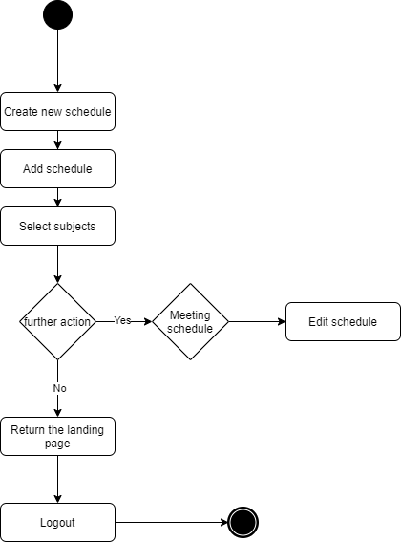

#### Figure: 4. Create new schedule Activity Diagram

The above diagram shows how the process of creating a schedule is, every schedule needs a subject, to make a schedule we need to select a subject as we showed in the activity diagram.

1. Share file

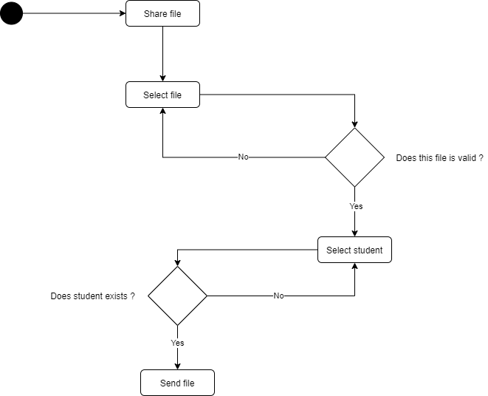

#### Figure: 4. Share file Activity Diagram

1. Logout

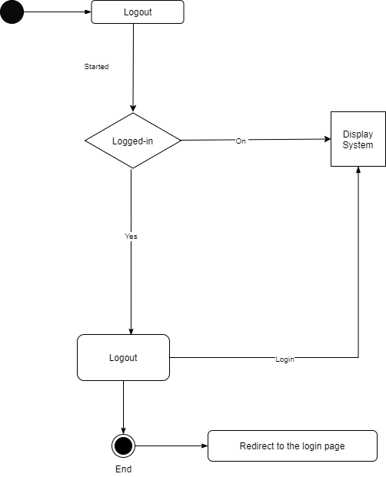

#### Figure: 4. Logout Activity Diagram

All the users including the administration would log out from one session, the system shares only one session.

## 4.2.3 Class Diagram

The purpose of the class diagram is to show the structure of the system, the class diagram provides a very basic notation for other structures, and it helps users to understand the system very well.



#### Figure: 4. Class Diagram

## 4.2.4 Mapping Cardinality

A mapping cardinality is a data constraint that specifies how many entities can be related to in a relationship set.

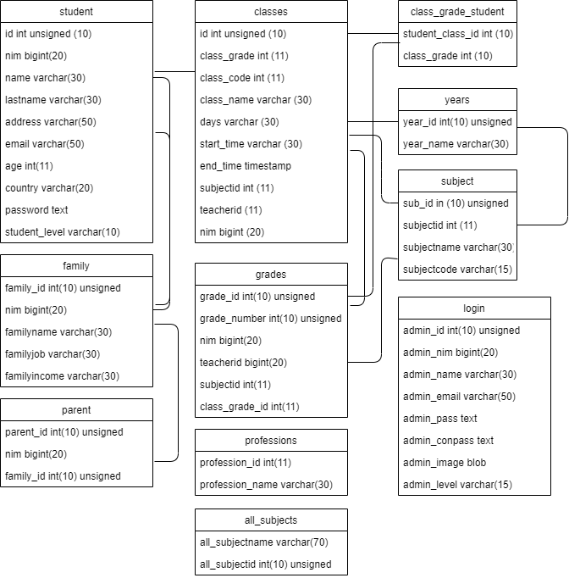

#### Figure: 4. Mapping Cardinality

## 4.2.5 Sequence Diagram

1. Login

This Sequence diagram shows the different parts a system work in a sequence to get something done. The below diagram shows the login sequence, how it functions to allow users inside the system. All users using from one login page, with different passwords and usernames, the system decides the authority who’s the admin who’s a teacher, and who’s the student.



#### Figure: 4. Login Sequence Diagram

1. Logout

Sequence logout, in this stage sequence, shows how users logged out from the system, every user logged out from one session. In logout users don’t need to put a password or username, the system just takes them out, the system doesn’t need for validation as well.

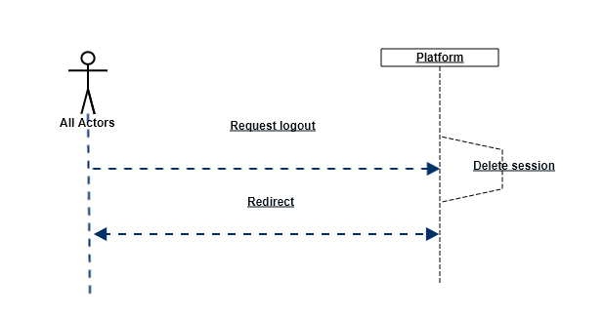

#### Figure: 4. Logout sequence

1. Administration

In this stage, the administration has the right to update, delete, and insert new teacher, student, or event can make new admin, any changes will be saved in the database.



#### Figure: 4. administration Sequence Diagram

1. Admission

The below sequence demonstrates the admission interaction with the objects.



#### Figure: 4. Admission Sequence Diagram

1. Student

The interaction of students with their account



#### Figure: 4. Student Sequence Diagram

1. Teacher

The below sequence shows the teacher's interaction with classes and teachers.



#### Figure: 4. Teacher Sequence Diagram

## Crud Matrix

A crud matrix is a table showing the functions in an application containing the SQL, MongoDB, Oracle, MySQL statement affecting parts of the database. We use crud to identify the tables in a database that are used in any user interaction with a web site.

|  |  |  |  |  |  |  |  |  |  |  |  |
| --- | --- | --- | --- | --- | --- | --- | --- | --- | --- | --- | --- |
| Attributes | Student | Classes | Class-grade-student | Years | Subject | Grades | Family | Parent | All_subject | professions | Login |
| student | CRUD | RU | RU | RU | RU | RU | RU | RU | RU | RU | RU |
| id | CR | R | R | R | R | R | R | R | R | R | R |
| nim | CR | RU | RU | RU | RU | RU | RU | RU | RU | RU | RU |
| name | CR | RU | RU | RU | RU | RU | RU | RU | RU | RU | RU |
| last name | CR | RU | RU | RU | RU | RU | RU | RU | RU | RU | RU |
| last name | CR | RU | RU | RU | RU | RU | RU | RU | RU | RU | RU |
| address | CR | RU | RU | RU | RU | RU | RU | RU | RU | RU | RU |
| country | CR | R | R | R | R | R | R | R | R | R | R |
| password | CR | U | U | U | U | U | U | U | U | U | U |
| classes | CRUD | RU | RU | RU | RU | RU | RU | RU | RU | RU | RU |
| class_id | CR | R | R | R | R | R | R | R | R | R | R |
| class_student_grade | CR | RU | RU | RU | RU | RU | RU | RU | RU | RU | RU |
| class_student_code | CR | RU | RU | RU | RU | RU | RU | RU | RU | RU | RU |
| class_student_days | CR | RU | RU | RU | RU | RU | RU | RU | RU | RU | RU |
| class_student_start_time | CR | RU | RU | RU | RU | RU | RU | RU | RU | RU | RU |
| class_subject_id | CR | R | R | R | R | R | R | R | R | R | R |
| class_teacher_id | CR | R | R | R | R | R | R | R | R | R | R |
| class_student_id | CR | RU | RU | RU | RU | RU | RU | RU | RU | RU | RU |
| Class-grade-student | CRUD | RU | RU | RU | RU | RU | RU | RU | RU | RU | RU |
| student_class_id | CR | R | R | R | R | R | R | R | R | R | R |
| class_grade | CR | R | R | R | R | R | R | R | R | R | R |
| years | CRUD | RU | RU | RU | RU | RU | RU | RU | RU | RU | RU |
| year_id | CR | R | R | R | R | R | R | R | R | R | R |
| year_name | CR | RU | RU | RU | RU | RU | RU | RU | RU | RU | RU |
| subject | CRUD | RU | RU | RU | RU | RU | RU | RU | RU | RU | RU |
| sub_id | CR | R | R | R | R | R | R | R | R | R | R |
| subjectid | CR | R | R | R | R | R | R | R | R | R | R |
| subjectname | CR | RU | RU | RU | RU | RU | RU | RU | RU | RU | RU |
| subjectcode | CR | R | R | R | R | R | R | R | R | R | R |
| grades | CRUD | RU | RU | RU | RU | RU | RU | RU | RU | RU | RU |
| grade_id | CR | R | R | R | R | R | R | R | R | R | R |
| grade_number | CR | CRU | CRU | CRU | CRU | CRU | CRU | CRU | CRU | RU | CRU |
| nim | CR | RU | RU | RU | RU | RU | RU | RU | RU | RU | RU |
| teacherid | CR | RU | RU | RU | RU | RU | RU | RU | RU | RU | RU |
| subjectid | CR | R | R | R | R | R | R | R | R | R | R |
| class_grade_id | CR | RU | RU | RU | RU | RU | RU | RU | RU | RU | RU |
| family | CRUD | RU | RU | RU | RU | RU | RU | RU | RU | RU | RU |
| family_id | CR | R | R | R | R | R | R | R | R | R | R |
| nim | CR | RU | RU | RU | RU | RU | RU | RU | RU | RU | RU |
| familyname | CR | RU | RU | RU | RU | RU | RU | RU | RU | RU | RU |
| familyjob | CR | RU | RU | RU | RU | RU | RU | RU | RU | RU | RU |
| familyincome | CR | RU | RU | RU | RU | RU | RU | RU | RU | RU | RU |
| parent | CRUD | RU | RU | RU | RU | RU | RU | RU | RU | RU | RU |
| nim | CR | R | R | R | R | R | R | R | R | R | R |
| family_id | R | R | R | R | R | R | R | R | R | R | R |
| all_subjects | CRUD | RU | RU | RU | RU | RU | RU | RU | RU | RU | RU |
| all_subjectname | CRU | RU | RU | RU | RU | RU | RU | RU | RU | RU | RU |
| all_subjectid | CR | R | R | R | R | R | R | R | R | R | R |
| professions | CRUD | RU | RU | RU | RU | RU | RU | RU | RU | RU | RU |
| profession_id | CR | R | R | R | R | R | R | R | R | R | R |
| profession_name | CR | RU | RU | RU | RU | RU | RU | RU | RU | RU | RU |
| login | CRUD | RU | RU | RU | RU | RU | RU | RU | RU | RU | RU |
| Admin_id | CR | R | R | R | R | R | R | R | R | R | R |
| admin_nim | CR | RU | RU | RU | RU | RU | RU | RU | RU | RU | RU |
| name | CR | RU | RU | RU | RU | RU | RU | RU | RU | RU | RU |
| email | CR | RU | RU | RU | RU | RU | RU | RU | RU | RU | RU |
| password | CR | U | U | U | U | U | U | U | U | U | U |
| confirm password | CR | U | U | U | U | U | U | U | U | U | U |
| role | CR | RU | RU | RU | RU | RU | RU | RU | RU | RU | RU |

Table: 4. Crud Matrix

## 4.2.7 Database Scheme

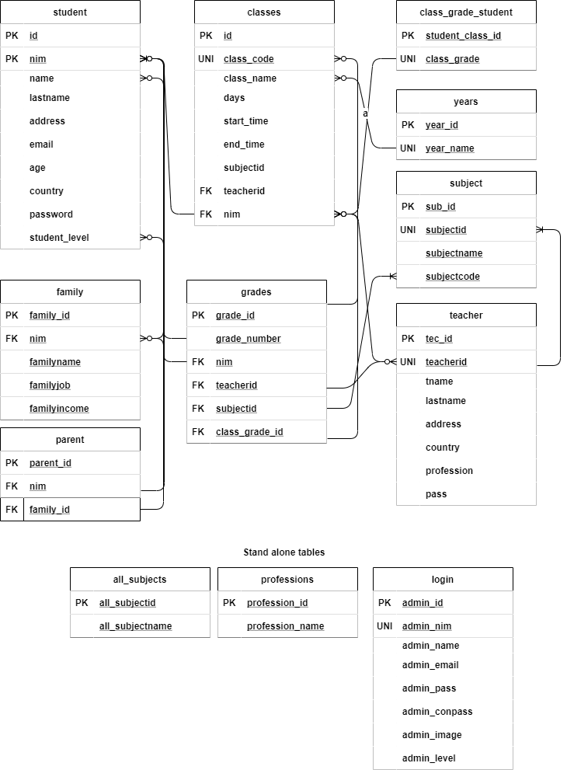

#### Figure: 4. Database Schema

## Database Specification

1. Login

Table Name : Login

Primary key : ID

Type of table : General

#### Table: 4. User Specification

|  |  |  |  |  |
| --- | --- | --- | --- | --- |
| No. | Field | Type | Size | Information |
| 1 | Id | INT | 10 | INT  1: ADMIN_ID PRIMARY KEY AUTO_INCREMENT |
| 2 | Student_nim | GIGINT | 20 | UNIQUE |
| 3 | Teacher_nim | BIGINT | 20 | UNIQUE |
| 4 | Admission_id | BIGINT | 20 | UNIQUE |
| 5 | Admin_nim | BIGINT | 20 | UNIQUE |

1. Login

Table Name : Login

Primary Key : ID

Table type : Login

#### Table: 4. Admin Specification

|  |  |  |  |  |
| --- | --- | --- | --- | --- |
| No. | Field | Type | Size | Information |
| 1 | Id | INT | 10 | INT  1: ADMIN_ID PRIMARY KEY AUTO_INCREMENT |
| 2 | Admin_nim | BIGINT | 20 | UNIQUE |
| 3 | Admin_name | VARCHAR | 30 | NOT NULL |
| 4 | Admin_lastname | VARCHAR | 30 | NOT NULL |
| 5 | Admin_email | VARCHAR | 50 | NOT NULL |
| 6 | Admin_pass | TEXT | - | NOT NULL |
| 7 | Admin_conpass | TEXT | - | NOT NULL |
| 8 | Admin_level | VARCHAR | 15 | NOT NULL |

1. Student

Table Name : Student

Primary Key : nim

Foreign Key : nim

Table Type : Student Registration

#### Table: 4. Student Specification

|  |  |  |  |  |
| --- | --- | --- | --- | --- |
| No. | Field | Type | Size | Information |
| 1 | id | INT | 10 | INT  1: ADMIN_ID PRIMARY KEY AUTO_INCREMENT |
| 2 | nim | BIGINT | 20 | UNIQUE |
| 3 | name | VARCHAR | 30 | NOT NULL |
| 4 | lastname | VARCHAR | 30 | NOT NULL |
| 5 | address | VARCHAR | 50 | NOT NULL |
| 6 | email | VARCHAR | 50 | NOT NULL |
| 7 | age | INT | 11 | NOT NULL |
| 8 | country | VARCHAR | 20 | NOT NULL |
| 9 | password | TEXT | - | NOT NULL |
| 10 | student_level | VARCHAR | 10 | NOT NULL |

1. Family

Table Name : family

Primary Key : Family_id

Foreign Key : Family_id

Table Type : Family info

#### Table: 4. Family Specification

|  |  |  |  |  |
| --- | --- | --- | --- | --- |
| No. | Field | Type | Size | Information |
| 1 | family_id | INT | 10 | INT  1: FAMILY_ID AUTO_INCREMENT  PRIMARY KEY |
| 2 | nim | BIGINT | 20 | FOREIGN KEY |
| 3 | familyname | VARCHAR | 30 | NOT NULL |
| 4 | familyjob | VARCHAR | 30 | NOT NULL |
| 5 | familyincome | VARCHAR | 30 | NOT NULL |

1. Parent

Table Name : parent

Primary Key : parent_id

Foreign key : nim

Foreign key : family_id

Table Type : Parents infor

#### Table: 4. Parents Specification

|  |  |  |  |  |
| --- | --- | --- | --- | --- |
| No. | Field | Type | Size | Information |
| 1 | parent_id | INT | 10 | INT: 1  AUATO_INCREMENT  PRIMARY KEY |
| 2 | nim | BIGINT | 20 | FOREIGN KEY |
| 3 | family_id | INT | 10 | FOREIGN KEY |

1. Classes

Table Name : classes

Primary key : id

Foreign key : subjectid

Foreign key : teacherid

Foreign key : nim

Table type : Classes info

#### Table: 4. Parents Specification

|  |  |  |  |  |
| --- | --- | --- | --- | --- |
| No. | Field | Type | Size | Information |
| 1 | id | INT | 10 | INT: 1  AUATO_INCREMENT  PRIMARY KEY |
| 2 | class_grade | INT | 11 | NOT NULL |
| 3 | class_code | INT | 11 | UNIQUE |
| 4 | days | VARCHAR | 30 | NOT NULL |
| 5 | start_time | VARCHAR | 30 | NOT NULL |
| 6 | end_time | TIMESTAMP | - | NOT NULL |
| 7 | subjectid | INT | 11 | FOREIGN KEY |
| 8 | teacherid | BIGINT | 20 | FOREIGN KEY |
| 9 | nim | BIGINT | 20 | FOREIGN KEY |

1. Subjects

Table Name : subjects

Primary key : sub_id

Foreign key : subjectid

Table Type : subjects info

#### Table: 4. Subjects Specification

|  |  |  |  |  |
| --- | --- | --- | --- | --- |
| No. | Field | Type | Size | Information |
| 1 | sub_id | INT | 10 | INT: 1  AUATO_INCREMENT  PRIMARY KEY |
| 2 | subjectid | INT | 11 | UNIQUE |
| 3 | subjectname | VARCHAR | 30 | NOT NULL |
| 4 | subjectcode | VARCHAR | 15 | NOT NULL |

1. Teachers

Table Name : teacher

Primary key : tec_id

Foreign key : teacherid

Table Type : teacher info

#### Table: 4. Teacher Specification

|  |  |  |  |  |
| --- | --- | --- | --- | --- |
| No. | Field | Type | Size | Information |
| 1 | tec_id | INT | 10 | INT: 1  AUATO_INCREMENT  PRIMARY KEY |
| 2 | teacherid | BIGINT | 20 | UNIQUE |
| 3 | tname | VARCHAR | 30 | NOT NULL |
| 4 | lastname | VARCHAR | 30 | NOT NULL |
| 5 | address | VARCHAR | 70 | NOT NULL |
| 6 | country | VARCHAR | 30 | NOT NULL |
| 7 | profession | VARCHAR | 30 | NOT NULL |
| 8 | pass | TEXT | - | NOT NULL |

1. Grades

Table Name : grades

Primary key : grade_id

Foreign key : nim

Foreign key : teacherid

Foreign key : subjected

Table Type : grades info

#### Table: 4. Grades Specification

|  |  |  |  |  |
| --- | --- | --- | --- | --- |
| No. | Field | Type | Size | Information |
| 1 | grade_id | INT | 10 | INT: 1  AUATO_INCREMENT  PRIMARY KEY |
| 2 | grade_number | INT | 10 | 0 |
| 3 | grade_string | CHAR | 1 | FOREIGN KEY |
| 4 | nim | BIGINT | 20 | FOREIGN KEY |
| 5 | teacherid | BIGINT | 20 | FOREIGN KEY |
| 6 | subjectid | INT | 11 | NOT NULL |
| 7 | class_grade_id | INT | 10 | NOT NULL |

1. Years

Table Name : years

Primary key : year_id

Table Type : Years Info

#### Table: 4. Years Specification

|  |  |  |  |  |
| --- | --- | --- | --- | --- |
| No. | Field | Type | Size | Information |
| 1 | year_id | INT | 10 | INT: 1  AUATO_INCREMENT  PRIMARY KEY |
| 2 | year_name | VARCHAR | 30 | UNIQUE |

1. Professions

Table Name : professions

Primary key : profession_id

Table Type : Professions of teacher

#### Table: 4. Professions Specification

|  |  |  |  |  |
| --- | --- | --- | --- | --- |
| No. | Field | Type | Size | Information |
| 1 | profession_id | INT | 11 | INT: 1  AUATO_INCREMENT  PRIMARY KEY |
| 2 | profession_name | VARCHAR | 30 | - |

1. Share files

Table Name : files

Primary key : file_id

Foreign key : teacherid

Foreign key : nim

#### Table: 4. Share file Specification

|  |  |  |  |  |
| --- | --- | --- | --- | --- |
| No. | Field | Type | Size | Information |
| 1 | file_id | INT | 11 | INT: 1  AUATO_INCREMENT  PRIMARY KEY |
| 2 | nim | BIGNINT | 20 | FOREIGN KEY |
| 3 | teacherid | BIGINT | 20 | FOREIGN KEY |
| 4 | file_title | VARCHAR | 30 | - |
| 5 | file_description | TEXT | - | - |
| 6 | file_attachement | BLOG | - | - |
| 7 | send_date | TIMESTAMP | - | - |

## 4.2.9 Menu Structure Design

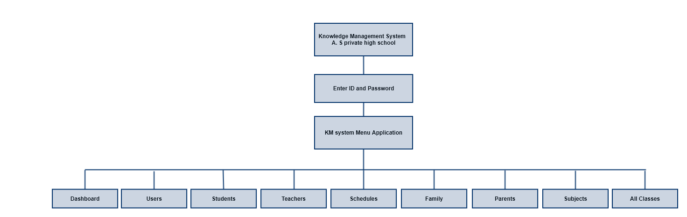

#### Figure: 4. Admin Menu Application

# **Interface Design**

Login



#### Figure: 4. Login Interface Design

Dashboard

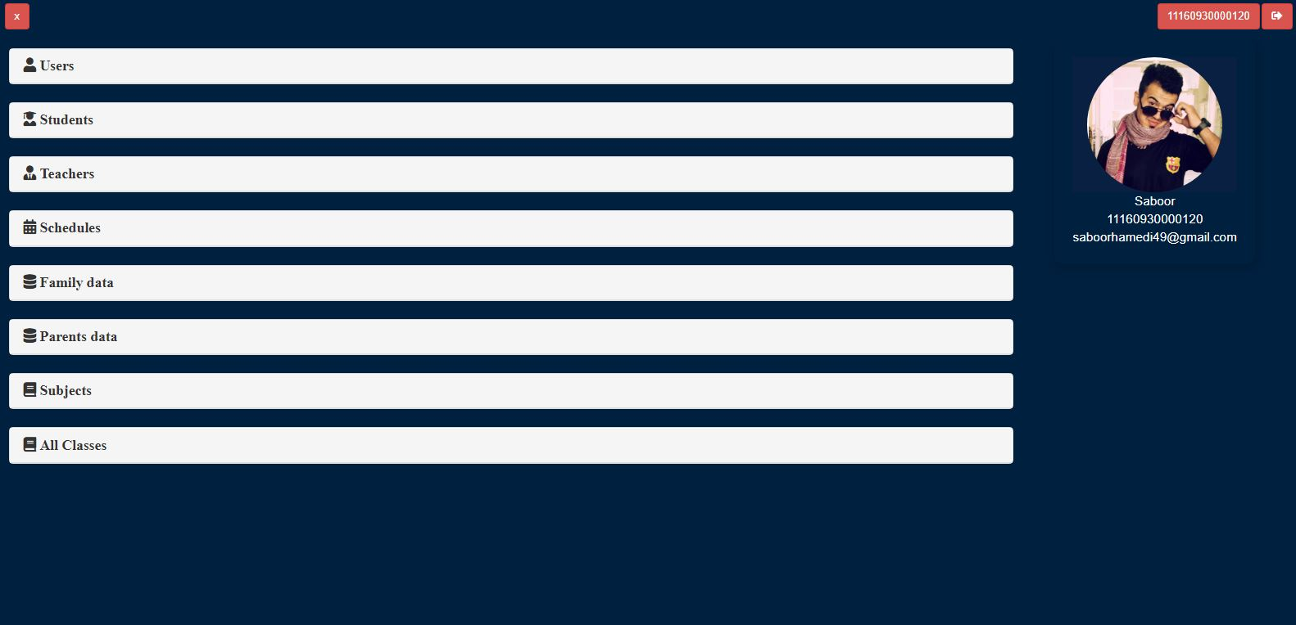

#### Figure: 4. Dashboard Interface Design

Student

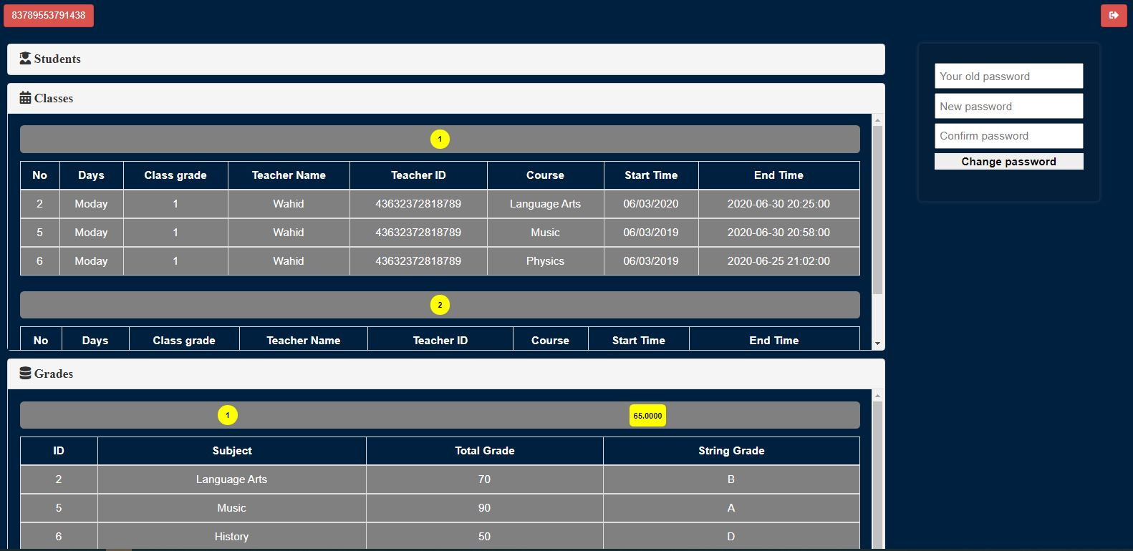

#### Figure: 4. Student Interface Design

Teacher

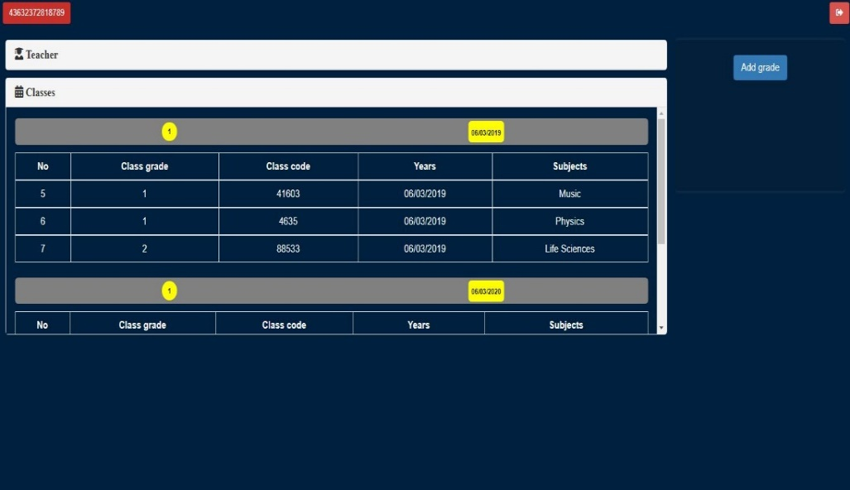

#### Figure: 4. Teacher Interface Design

Teacher add grade

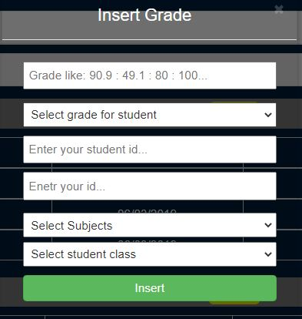

#### Figure: 4. Teacher add the grade

Register Student

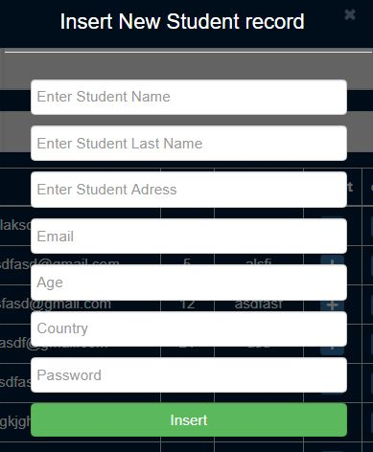

#### Figure: 4. Register Student Interface Design

Update Student

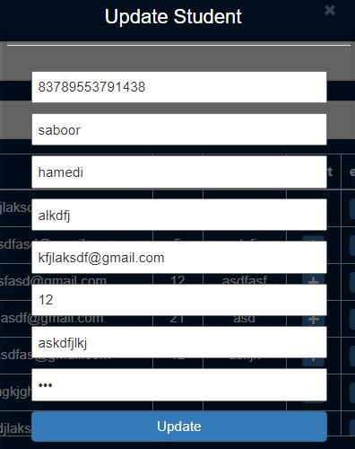

#### Figure: 4. Update Student Interface Design

Add New Teacher

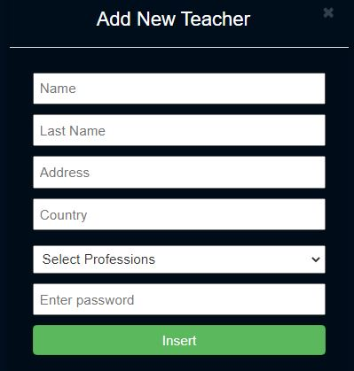

#### Figure: 4. Add New Teacher

Update Teacher

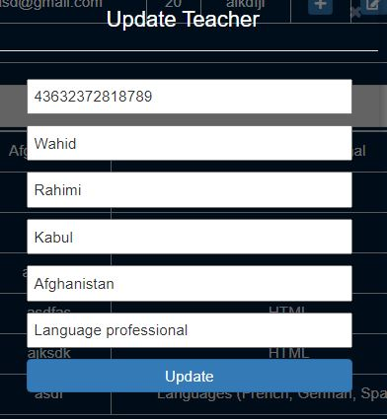

#### Figure: 4. Update Teacher

Settings

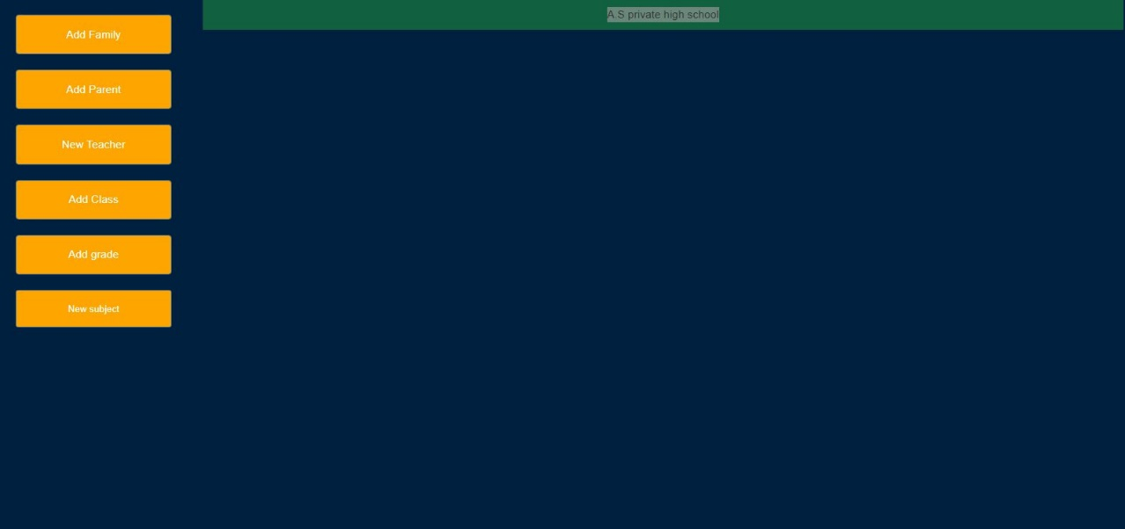

#### Figure: 4. Settings Interface Design

Add New Family

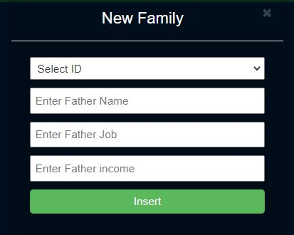

#### Figure: 4. Add New Family

Add New Parent

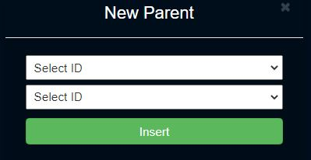

#### Figure: 4. Add New Parent

Add New Classes

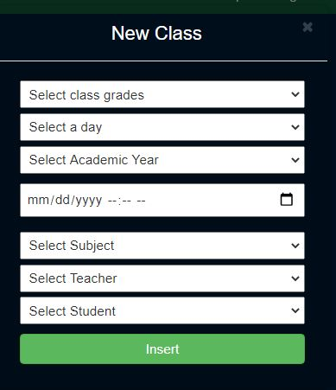

#### Figure: 4. Add New Classes

Add New Grade



#### Figure: 4. Add New Grades

Add New Subject

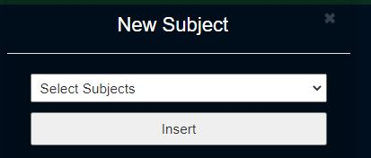

#### Figure: 4. Add New Subject

# **Implementation**

In the coding stage of the knowledge management system of A. S private high school we have used pure PHP programming language version 7.5, and MySQL as database as well phpMyAdmin for database management, we used visual studio code (VSC) for writing the script.

## 4.4.1 Testing

In this stage, we are using black-box testing or behavioral testing, the testing process carried out in the form of experiments and examination by running the system, as for the party that runs it the system in the testing process is (A. S private high school), this test shown as follows:

The testing displayed is based on the system namely:

1. Testing Login Menu

The Testing result for login design is shown in the table below:

#### Table: 4. Testing Login Menu

|  |  |  |  |  |  |
| --- | --- | --- | --- | --- | --- |
| No. | Design process | User | Expected result | Normalized | Result |
| 1 | Input ID and password click login | All actors | -If the ID and passwords are the same main page will open for use.  -If the ID or password is not the same an error message will show the wrong user or ID | Login Form  And Main  Page | Ok |

1. Testing Dashboard Menu

The Testing result for dashboard design is shown in the table below:

#### Table: 4. Testing Dashboard Menu

|  |  |  |  |  |  |
| --- | --- | --- | --- | --- | --- |
| No. | Design process | User | Expected result | Normalized | Result |
| 1 | Click Dashboard menu for registration, add, update, delete | All actors | -If the ID and Password are correct show the dashboard. | Dashboard Form and modals | Ok |

1. Students

The Testing result for student design is shown in the table below:

#### Table: 4. Testing Student Menu

|  |  |  |  |  |  |
| --- | --- | --- | --- | --- | --- |
| No. | Design process | User | Expected result | Normalized | Result |
| 1 | Click login in the student account | All actors | -If the ID and Password are correct to show the student. | Every student must see his/her account | Ok |

1. Teacher

The Testing result for teacher design is shown in the table below:

#### Table: 4. Testing Teacher Menu

|  |  |  |  |  |  |
| --- | --- | --- | --- | --- | --- |
| No. | Design process | User | Expected result | Normalized | Result |
| 1 | Click login in the teacher account | All actors | -If the ID and Password are correct to show the teacher. | Every teacher must see his/her account.  Add grade for the student | Ok |



# **CHAPTER V**

# **CLOSING**

# **5.1 Conclusion**

The manual system of the school was insecure consuming time and expose all the privacy of the students, with the new version of the student management system we enhanced the school performance and secured the privacy of each student and teacher.

This conclusion is based on the description and discussion in previous chapters, it can be concluded as follows:

In this thesis, the knowledge management documentation process is owned by A.S Private High School. Now data can be stored using computers and databases and data can be manipulated more effectively.

The result of this thesis is a student management system, in which student can see all their data within a personal account which will be made during registration.

Developing a web-based system for A. S private high school using PHP programming language and MySQL for storing data, MySQL database allows all students, teachers, to see their account as well as admin to control the system including information about a student and teacher.

# **5.2 Suggestion**

For further development of this research, I suggest investigate deeper about students, including staff, families, teachers the details are as follows:

Further research can extend more functionality for students to ease student activities like online socialization, an online library based on their grades.

Allow specific students on the system to contribute to other students, ask students for their opinion about the system.

MySQL is one of the best databases in the world, I suggest go for MariaDB, Oracle, or MongoDB, with more space.

PHP has lots of Libraries use one of them to make the system more professional and user friendly, if you are not comforted with PHP choose a different language, like Django, Node.js, or Java.

# **REFERENCES**

Amr Salah Hamed Ramadan Ali*, E. G. (2013). Mobile Apps Based Management Information System Using Cloud Computing in E-marketing and E-learning. *Management Information System*, 3.

Bergeron, B. (2003). Essentials of knowledge management. *Hoboken, New Jersey*.

C.K.Ow, R. W. (2001). Building a Knowledge-based Business School. *Education & Training. .2001, 43 (4/5): 268-274.*

Collings, D. G. (2009). Human resource management: A critical approach. In D. G. *A critical approach. In D. G.*

D. Shao, S. K. (2007). A Case for White-box Testing Using Declarative Specifications Poster Abstract,. *in Testing: Academic and Industrial Conference Practice and Research Techniques - MUTATION, 2007. TAICPART-MUTATION 2007, 2007, p. 137*.

G. J. Myers, T. B. (2004). The Art of Software Testing. John Wiley & Sons, 2004. *The Art of Software Testing. John Wiley & Sons, 2004*.

G. Natarajan, a. S. (2000). Knowledge Management. *McGraw Hill International Edition, Boston Burr Ridge, 2000*.

G. Probst, S. R. (2000). Managing Knowledge: Building Blocks for Success. *Building Blocks for Success 2000*.

GABRIEL, J. M. (2012). Management of Information Systems And Corporate. *Management Information System*, 3.

Gehani, N. (2006). The Database Book: Principles and practice using MySQL. *1st ed., Summit, NJ.: Silicon Press, (2006).*

Ira Mirawati, J. R. (2009). Student Appreciation toward Online Learning Management System. *Student Appreciation toward Online Learning Management System*, 2.

Klopper, R. G. (2007). Assessment of a framework to compare software development methodologies. *Proceedings of the 2007 Annual Research Conference of the South African Institute of Computer Scientists and Information Technologists on IT Research in Developing Countries, 56-65. doi: 10.1145/1292491.1292498.*

Leidner, M. A. (2001). Review: Knowledge Management and Knowledge Management Systems Conceptual Foundations and Research Knowledge Management Systems Conceptual Foundations and Research Knowledge Management Systems Conceptual Foundations and Research Issues. *MIS Quarterly vol. 25(1), pp. 107-136, 2001*.

M. R. Keyvanpour, H. H. (2011). Automatic Software Test Case Generation,. *Journal of Software Engineering, vol. 5, no. 3, pp. 91–101, Mar. 2011.*

M. Santosus, a. J. (2001). The ABCs of Knowledge Management. CIO. *The ABCs*.

M. Sharma and B. S. Chandra. (2010). Automatic Generation of Test Suites from Decision Table - Theory and Implementation. *in Software Engineering Advances (ICSEA), 2010 Fifth International Conference on, 2010, pp. 459 –464*.

Meijer, D. K. (2010). Information: what do you mean. *Information*, 15.

Nowduri, S. (2006,2010). Management information systems and business decision making:. *Management information systems*, 2.

Piccoli, G., & Pigni, F. (July 2018). Information systems for managers. *with cases (Edition 4.0 ed.). Prospect Press. p. 28*.

Rune Pettersson, P. e. (2007). Information Design–Principles and. *Information Design*, 2.

Shaw, M. (2002). What makes good research in software engineering?,. *International Journal on Software Tools for Technology Transfer (STTT), vol. 4, no. 1, pp. 1–7, 2002*.



APPENDIX

# **APPENDIX 1**

# **INTERVIEW**

Interviewees **:** Mr. Muhmmad Nadir

Questioner  **:** Abdul Saboor Hamedi

1 What is the big issue of the school?

Consuming time, It’s one of the big challenges we’re facing, every teacher has the responsibility to collect information about their students for giving the grades.

2 How is the registration system?

In our school, A. S private high school everything is manual we ask students about their biodata, like name, last name, email, nationality, and some other information and we write them in a piece of paper and keep them on the yearly document.

3 What about the student family, do you know the student’s family?

Yeas we do know them, this our responsibility, it’s the same as the student registration method, but don’t go so deep about family, we ask them their names jobs, and incomes, and we save it in the families' document.

4 How is the grade announcing system?

Every teacher is responsible for distributing the grades, every teacher should give grades at the end of the academic year.

# **THESIS ACKNOWLEDGEMENT**

Assalamu’alaikum wr. wb.

All praise be to Allah S.W.T who has given me all these opportunities, to finish this thesis successfully. Indeed, without support and help of my lecturers I would never been able to finish my thesis, I’m grateful to have lecturer like them and I would like thanks to:

1. Mrs. Prof. Dr. Lily Surraya Eka Putri, M.Eka.Stud. The deen of faculty of science and technology UIN Syarif Hidayatullah Jakarta.
2. Mr. A’ang Subiyakto, Ph.D. The head of science and technology UIN Syarif Hidayatullah Jakarta.
3. Mrs. Nida’ul Hasanati, S.T. MMSI secretary of faculty of science and technology UIN Syarif Hidayatullah Jakarta.
4. Mrs. Evy Nurmiati, MMSI, lecturer of UIN Syarif Hidayatullah Jakarta.

That accept me to continue this thesis under their guidance. I start writing my thesis at the beginning of COVID-19 and I acknowledge plagiarism

Sunday, August 20, 2020

**Abdul Saboor Hamedi**

11160930000120

# **APPENDIX 2**

# **LETTERS**

Note: I have not received the letters yet, after all my revision is done, Prodi will send me those letters.

# **APPENDIX 2**

# **USER INTERFACE**

Login



Dashboard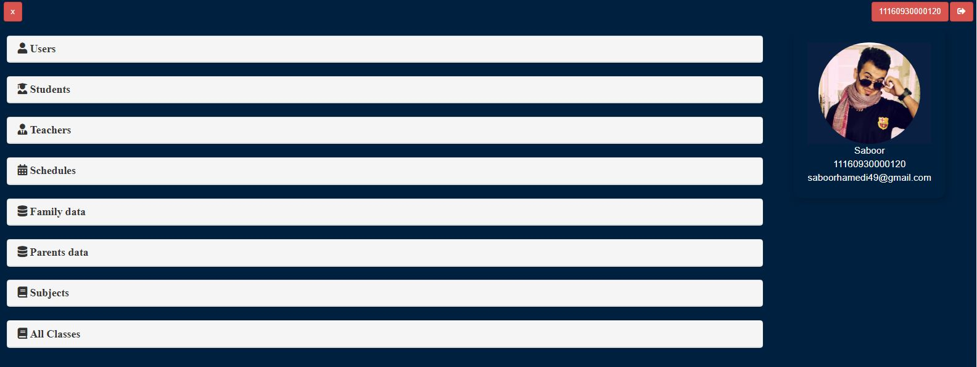

Admin Users

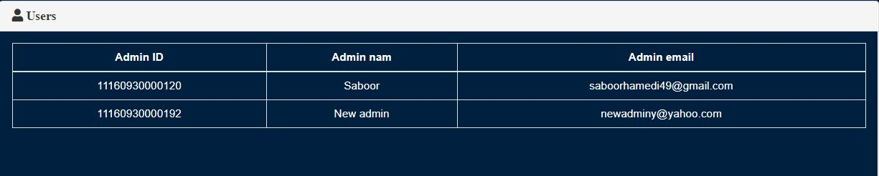

Student Data

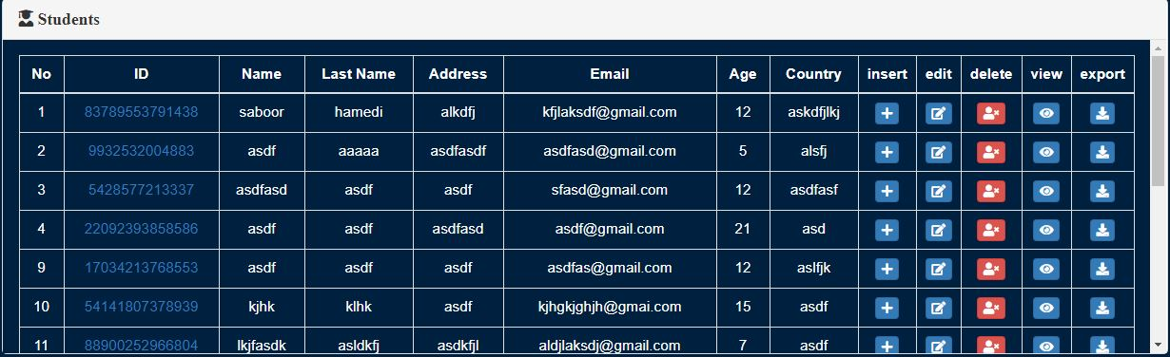

Teacher Data

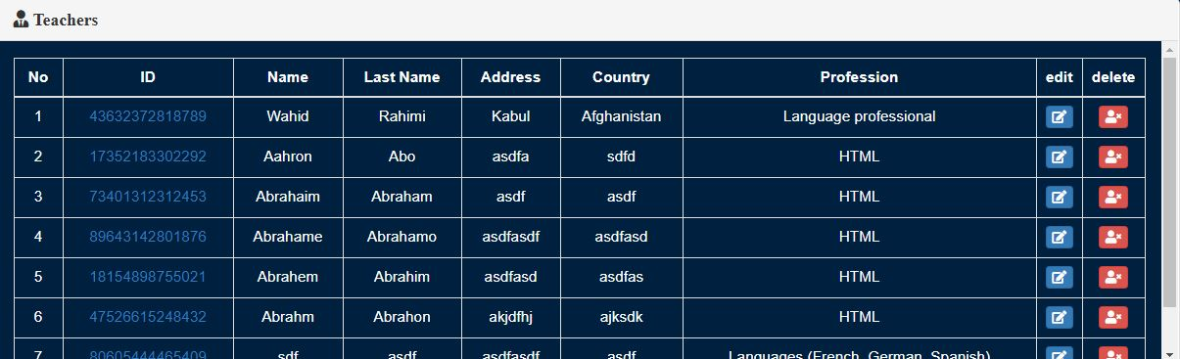

Schedules

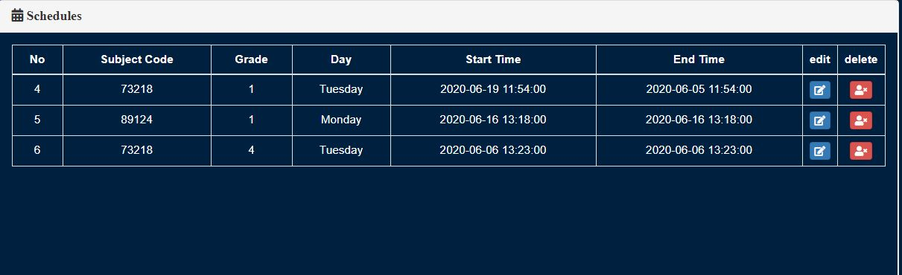

Family Data

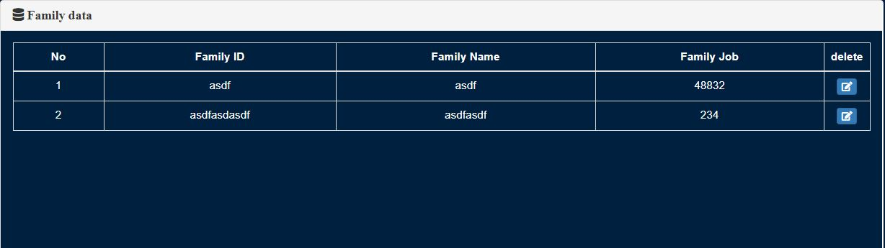

Parent Data

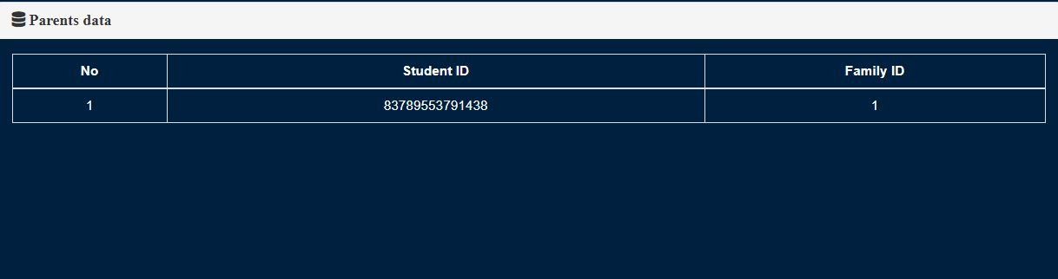

Subjects

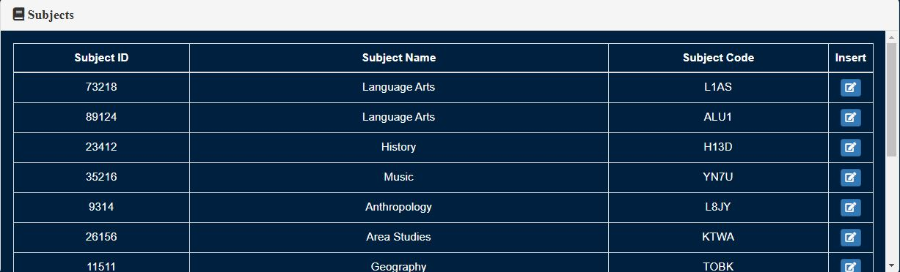

All Classes

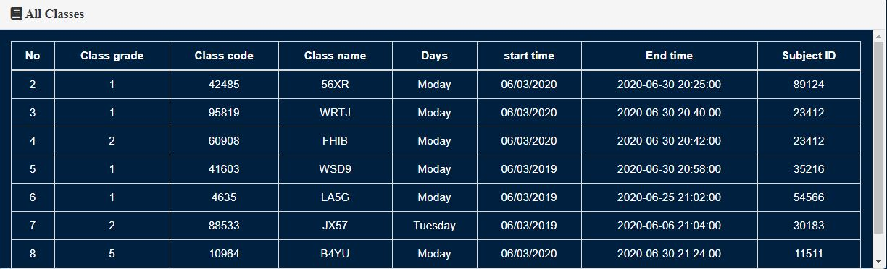Add new Admin

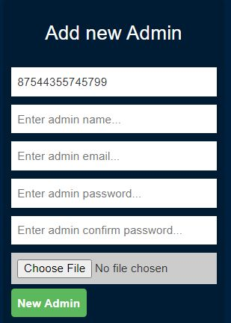

Register New Student

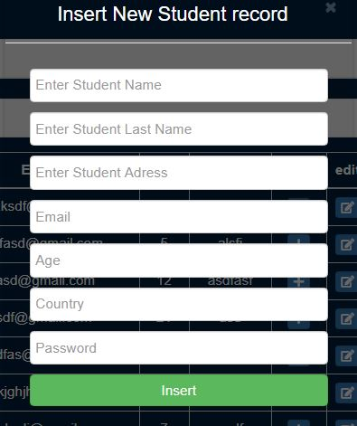

Add New Teacher

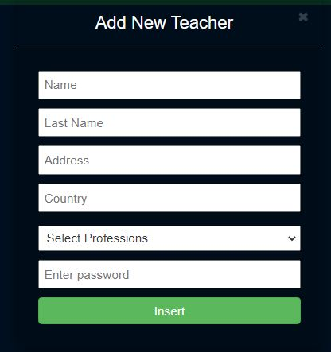

Add New Family

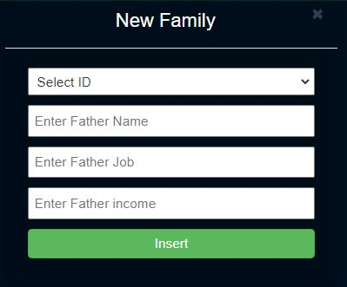

Add New Parent

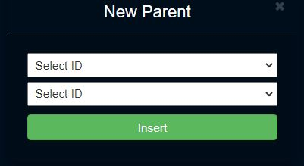

Add New Classes

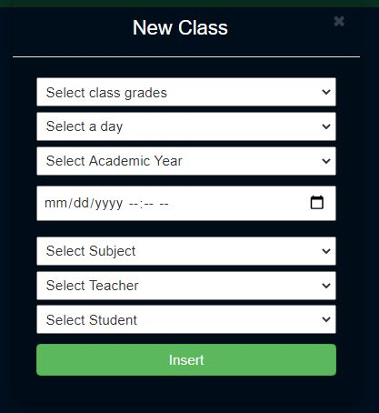

Add Grades

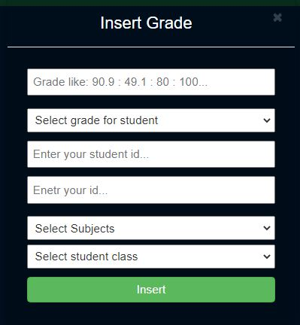

Student Account

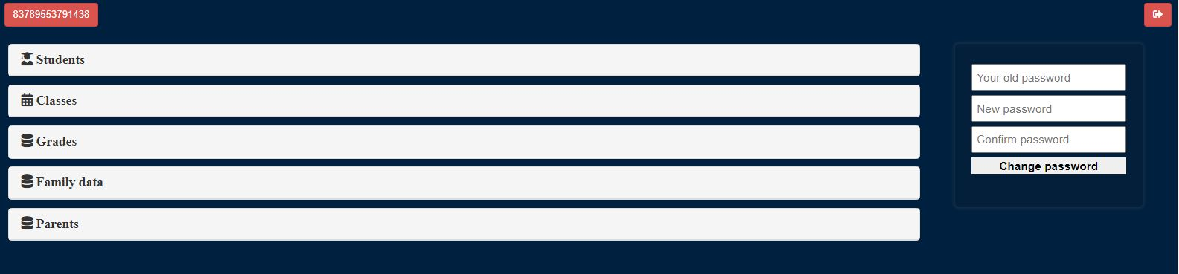

Student Class Grade

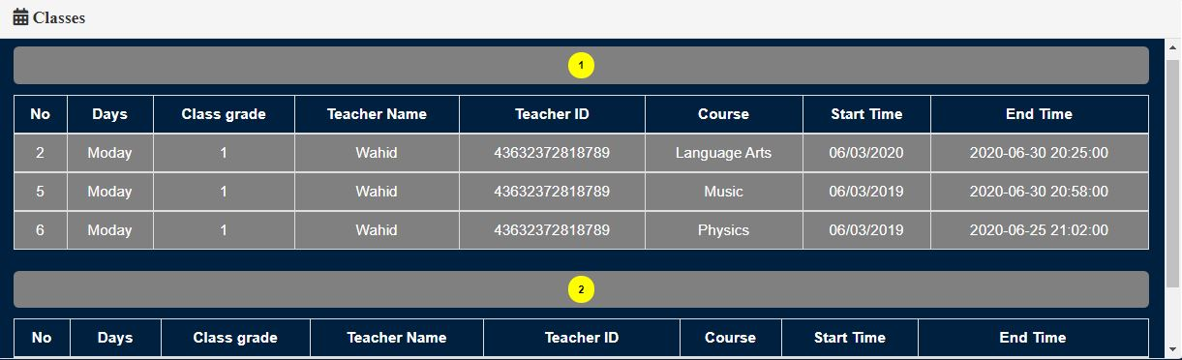

Student Grades

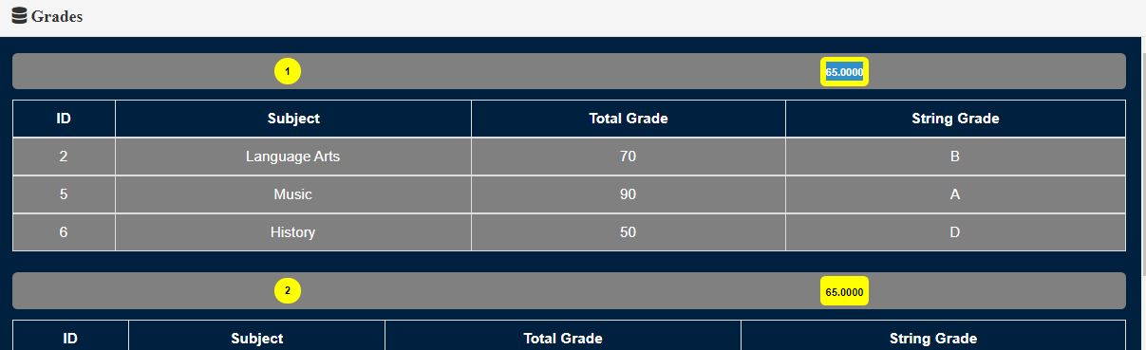

Teacher Account

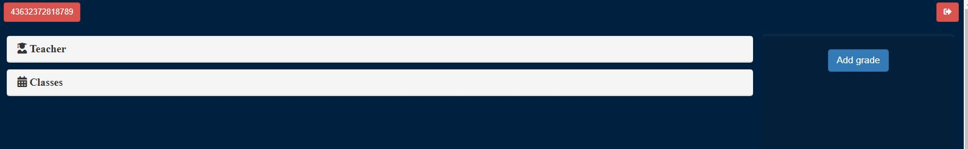

Teacher Classes

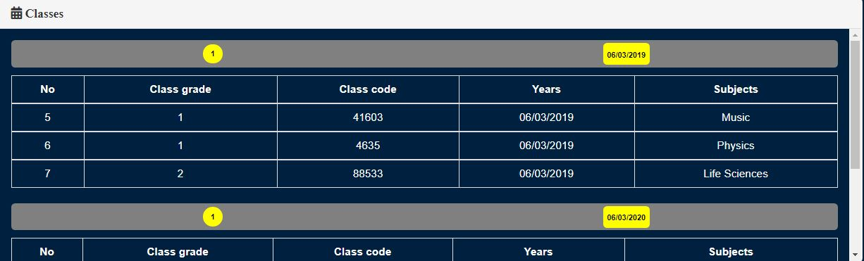

Teacher Add Grades

